## 

Residual

10.15.2018

Howard Krieger and Ryan Medlin

Residual Token, Inc. (“Residual”)

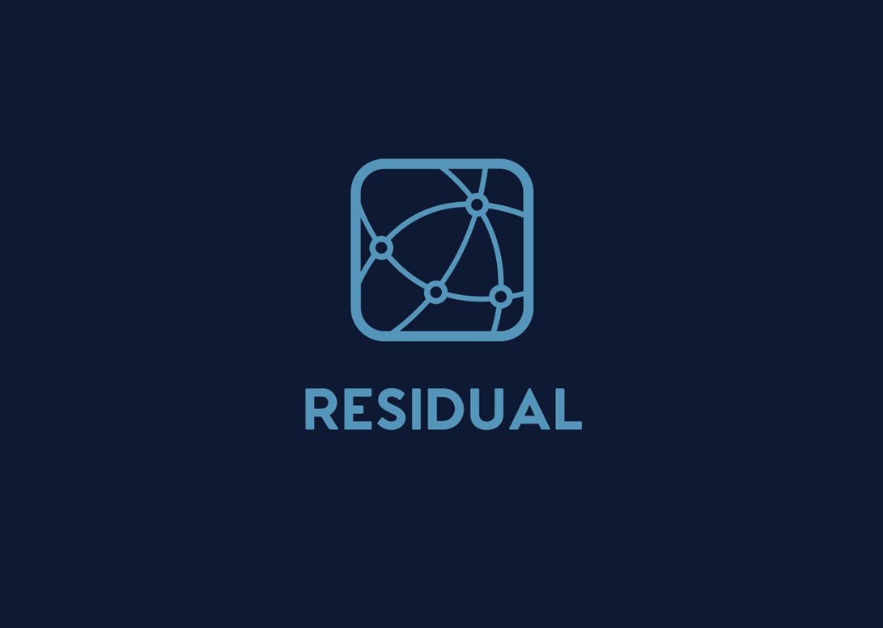A Delaware Corporation

**The Digital Asset Lending Ecosystem**

***Designed by Experienced Lending, Custodial and IT Professionals***

Copyright 2018 Residual Token, Inc.

Without explicit permission, anyone has the right to use, reproduce or distribute any material in this white paper for non-commercial purposes and educational use, provided that the original source and the applicable copyright notice are cited.

# Disclaimer

DISCLAIMER: This whitepaper is intended for distribution solely on information purposes. Residual Token, Inc. (“Residual”) does not guarantee the accuracy of the conclusions and statements reached in this whitepaper. Moreover, this white paper is provided "as is" with no representations and warranties, express or implied, whatsoever, including, but not limited to: (i) warranties of merchantability, fitness for a particular purpose, title or non-infringement; (ii) that the contents of this whitepaper are free from error or suitable for any purpose; and (iii) that such contents will not infringe third-party rights. All warranties are expressly disclaimed. Residual Token, Inc. and its affiliates expressly disclaim all liability for and damages of any kind (direct or indirect, including loss of profit) arising out of the use, reference to, or reliance on any information contained in this whitepaper, even if advised of the possibility of such damages. Under no circumstances Residual or its affiliates will be liable to any person, entity, partners, partner’s customer or end-users for any consequential, incidental, direct, indirect, special or punitive damages, including without limitation damages for lost profits, revenues, lost business or loss of use of products whether or not Residual advised in this whitepaper or any of the content contained herein, that such damages will or may occur, and whether such damages are claimed based on breach of contract, negligence, strict liability in tort or any other legal or equitable theory. No action regardless of form, arising out of this whitepaper may be brought against Residual. **This is not an offer to sell or purchase or solicit for sale or purchase securities. This whitepaper has not been filed or provided to the Securities and Exchange Commission.**

Table of Contents

Disclaimer 1

Synopsis 5

Overview 6

Problem Statement 6

The Solution 7

Advanced Lending Toolkit® 10

Relationships Between the Parties 10

Build-Out Timeline and Token Sale 13

The Token Sale 15

Allocation 16

Use of Residual Pool 17

Unsold Tokens & Team Vesting 18

Private Sale 19

PRE-SALE 19

Our pre-sale will coincide with two events: 19

Public Crowdsale 19

Crowdsale Start and End Date 20

How can I participate? 20

Funding Allocation 20

50% Development 20

20% Marketing & Growth 20

5% Security 21

20% Legal 21

5% Hosting & Infrastructure 21

Tokenomics 21

Distribution to RSDL-L Holders 23

Findings 24

The Minimum 24

Voting Rights 24

Certificates of Public Need – An Anology 25

Economic Theory 26

Open Source Concept 27

Our Competitive Advantage 27

An Abridged Origin of Currency 31

Founders 32

Howard Krieger 32

Ryan Medlin 32

Key Advisors (Alphabetically Listed) 33

Future Engineering Team 33

Statutory Lending Laws and Compliance 34

Know Your Customer and Anti-Money Laundering Compliance 34

Borrower Considerations 35

Management Services Implementation 36

Fee Structure 36

Residual Tokens – RSDL Derivatives 37

PLATFORM to INCENTIVIZE COMMUNITY 37

RSDL-D To Represent THE DEBT ASSETS 37

RSDL-U To Represent UNFUNDED LOANS 38

RSDL-F To Represent FAILED LOANS 38

RSDL-E To Represent ESCROW/TITLE AGENT ASSETS 38

RSDL-B To Represent BORROWERS 38

RSDL-R To Represent LENDERS 38

Technical Overview 39

Key Tenets of Residuals Technical Design and Implementation 39

Importance of Decentralization 39

Ethereum Platform 39

Security 40

The RSDL Protocols 40

Asset Verification 40

Asset Class Types 41

Bitcoin 41

Altcoins 41

ERC-20 tokens 41

ENS Names 41

Non Fungible Tokens (Distinguishable digital assets) 41

Borrower Application Processing Protocol 42

Collateral Valuation Protocols 43

Asset Escrow/Title Protocols 43

Loan Pricing Oracle Protocol 44

Lending (Funding) Protocols 44

Loan Servicing Protocols 44

Reporting and General Administration Protocols 45

Application of protocol for our First Real World Application 45

Evolution of the Protocol and Ecosystem 46

ERC721 Non Fungible Assets 46

Importance of EIP 820 46

Importance of IntEgration with NumerouS Blockchains 46

Relationships and Associations 47

Residual Foundation Governance Model 47

Development Roadmap 47

Q4 2018 47

Q1 2019 47

Q2 2019 48

Q4 2019 48

Q1 2020 48

Q2 2020 48

Third Party security review 48

Architecture Review 48

Residual Ecosystem Diagram 50

Why we are different than “Lending” Platforms 50

Deployment 51

Legal 51

Key Team Members 52

Howard Krieger, ASA, CEIV 52

Professional and Industry Experience 52

Technical Skills 53

Professional Affiliations 53

Ryan Medlin 53

Technical Skills 54

Professional and Industry Experience 54

NOT AN OFFER TO SELL OR BUY SECURITIES 54

RISKS 55

APPENDIX 1: ADDITIONAL TECHNICAL INFORMATION 59

# Synopsis[1]

We are building a web platform:

* For bona fide **Lenders** which allows people or companies to borrow money using their Digital Assets as collateral;
* For bona fide **Custodians** and **Escrow Agents** who are prepared to manage the challenge of their services where digital assets are the subject interest;
* For bona fide **Servicers** looking to bring in the tried, tested and mandated consumer and commercial loan servicing requirements for digital asset-backed loans;
* For **Consumer and Commercial** **Borrowers** seeking liquidity, security and best in class execution; and
* For anyone interested in the data associated with digital asset-backed lending counterparties, transaction data and loan performance.

It is designed for small to medium-sized lenders looking to realize positive ROI as their industry evolves a digital asset-supported product model. It will be simply be another product line for them, and open the doors to tremendous stores of assets and production.

Debt was civilization’s first currency and medium of exchange. Economies relied on trust displayed over long periods of time among well-known associates to operate. Fiat currency requires multiple parties to trust in the same sovereign backer. This development freed up parties to transact globally through a common exchange. These transactions occur among centralized data aggregators or ledgers and require massive human labor to manage, monitor, and maintain. And still gaps in information exist. By putting assets on the blockchain everyone can track custody of discrete packets of information across decentralized ledgers. This is why we encourage digital assets (e.g. Bitcoin®, Ethereum®, LiteCoin®, etc.,) in our economy. Trustless systems and global scalability will decrease cost of borrowing and increase security. We expect the positive rate of change for the global economy to be consistent with the rate resulting from prior major financial innovations.

Residual Token, Inc.’s enterprise grade digital asset lending platform is for Lenders and the Borrowers with whom they do business.

Residual promotes digital asset-backed debt financing to expand individual Borrower access to liquidity by empowering professional Lenders with a modernized version of the traditional lending framework. A simple and intriguing bridge from old to new.

The large, established lenders, banks, and other financial institutions are racing to develop blockchain solutions and across the process landscape to drop lending costs, increase security, increase profitability and obtain market share.

# Overview

A gap exists between traditional fiat lending and digital asset-backed lending. The divide is marked by safe, long-standing, regulated lending practices on the one side, and highly specialized engineers with big ideas on the other. Our open-source, lending management protocols and vast traditional fiat lending experience bridges this gap. Our protocols expand traditional lenders’ existing product lines, optimizes its origination processes and automates servicing capabilities. Built on the blockchain, our system is mostly trustless with the exception of certain assessment protocols, information privacy modules and fund transfer activity.

## Problem Statement

Popular digital assets attract hundreds of billions of dollars in investment, but illiquidity depresses the value of those holdings and increases risk to the holder. As of July 2018, almost $270 billion dollars in digital currency was in circulation. This series of diagrams illustrates the challenges digital asset holders have as a result.

**Diagram I: Borrower’s Dilemma**

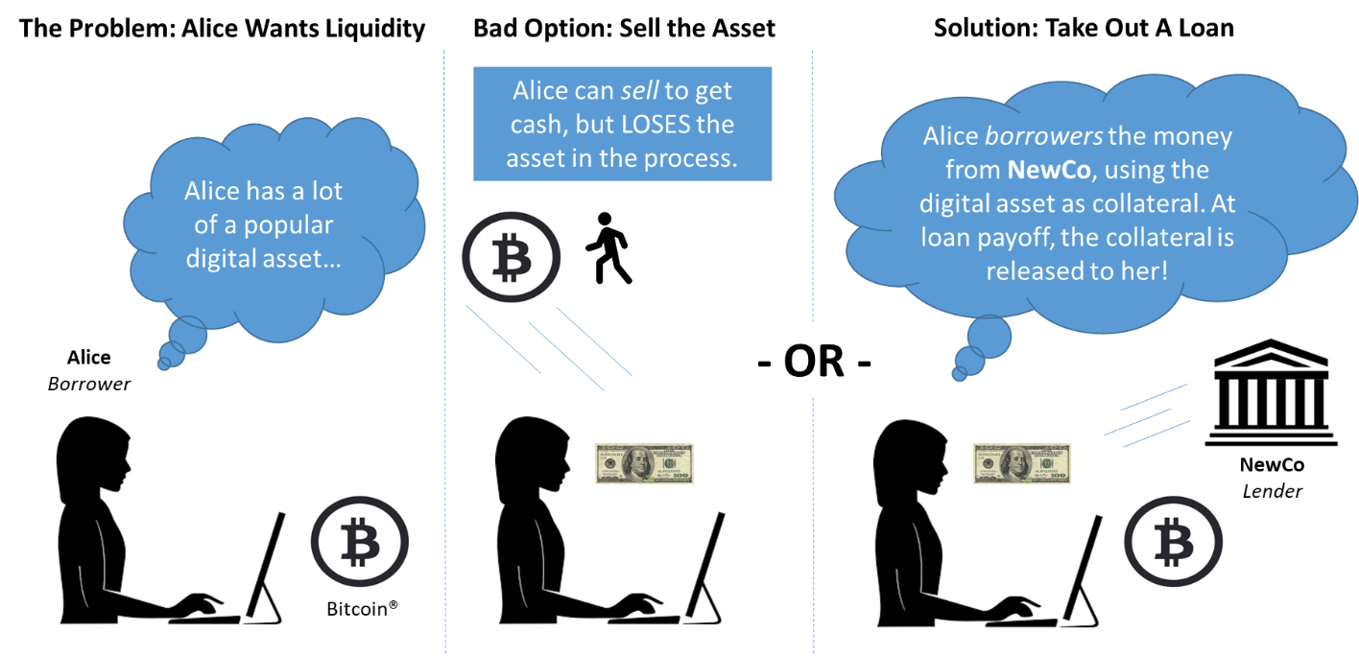

## The Solution

Traditional fiat lenders have been dealing with the issues of properly pricing risk and streamlining operations for centuries. In the flat and falling interest rate markets of the last 20 years, earning decent margins was achievable. Ever constrictive lending regulations and rising borrowing costs challenge profitability. To quote the Mortgage Banking Association in its 4Q16[2] article on independent originators, “…lenders reported a combination of both lower revenues and higher expenses. On the revenue side, secondary marketing income dropped as mortgage lenders wrestled with less favorable pricing and pipeline challenges. At the same time, production expenses per loan rose as fixed costs were spread over fewer loans.”

Based on feedback from our Advisors, we isolated four Lender hot-spots which encapsulate some medium- and long-term concerns:

* Rising interest rates leading to margin compression;
* Post-crisis generation weary to debt-load;
* Wage pressure increasing origination, servicing and collection costs;
* Increased personal information data security; and
* Pressure to automate processes while disruptive technology takes market share.

Our series of protocols are for:

* **Borrowers**: Digital asset holders consisting of individual consumers and commercial enterprises are afforded the ability to borrow against their digital asset at market rates by obliging themselves to typical credit enhanced terms and conditions. In the future this will not be limited to digital currency but all assets put on the blockchain (e.g. accounts receivable, medical billings, export/import bills of lading, etc.), and
* **Lenders[3]:** Entities participating or looking to participate in the digital asset environment backstopped by tried and tested lending policies and procedures using our commercial grade applications receive the following benefits:
  + As it relates to the application:
    - 24/7 technical support from live persons;
    - Robust interfacing with the various decentralized and centralized systems;
    - Technical training and documentation sufficient to support audit requirements;
    - FAQs
  + Market Dynamics:
    - Ability to charge financing rates tied to uncertain collateral value and limited market participants;
    - Post-crisis generation appeal – Target market likes holding assets and to optimize financing charges;
  + Shared technology investment
    - No single Lender need fund in its entirety the IPRD related to this new product;
    - A decentralized, encrypted platform running on security protocols which exceed the current mandate; and
  + Significant Potential
    - Advisory services;
    - Phased build-out; and
    - Borrower education plans expand market.

NewCo will be our example Lender, and we will document throughout this narrative its relationship to the ecosystem created by Residual and its protocols. By late fall/early winter of 2018, our basic, open source protocols will be in place and operational. Our strong lender partnerships will adopt the open source structure, and we expect to have in place at least 10 lenders by April 2019 if not exponentially more.

protocols.

* **Custodians/Escrow Agents**: Borrowers seek and entitled to secure and expeditious funds transfer upon execution of a loan agreement or as it pertains to the disposition of collateral. Lenders want to focus on making good loans and staying in compliance with rules and regulations regarding the management of loan collateral. Residual uses bona fide, licensed escrow and custody agents to support the flow of capital in conjunction with the goals of a decentralized platform. Residual’s future state will allow for services providers in this area to compete for business on the platform, while currently one such national provider is helping us design/implement the system out of the gate.
* **Servicing**:Residual intends to service the initial population of loans all Lenders originate. Part of the rationale includes being able to produce useful information for RSDL-L token holders, and to manage some of the higher order data requirements necessary to maintain the Advanced Lending Toolkit®[4], described in the token sale section of the document. Residual’s future state will allow for services providers in this area to compete for business on the platform, while currently one such national provider is helping us design/implement the system out of the gate.

The decentralized ledger blockchain model cuts out intermediaries and provides a trustless yet fully auditable framework. Adding liquidity to the nascent digital asset economy, adds monetary velocity, allows for the diversification of risk and increases the entire digital asset economy’s value[5].

Residual Token, Inc. designs the protocols, writes the protocols, provides documentation, and offers training to adopters of the lending platform. As an additional ecosystem feature, all RSDL-L token holders, described later in this document, will have access to articles, blog post, videos and performance and environmental data[6].

Our ecosystem simply consists of:

* An operating company to act as technology provider and servicer;
* A distributed app;
* Open source protocols;
* Relationships with various professional services companies, and
* Borrowers and participating Lenders.

# Advanced Lending Toolkit®

Our protocols are open-source, but the execution of a lending platform requires services beyond what is currently available via simple programming. Manual processes, quality control procedures, regulatory and compliance needs all have to be considered in delivering the complete package. Lenders are supported by Residual to accomplish and meet those other considerations on a best efforts basis.

Anyone can download the open source code and procedure manual (also available online) to begin operating a lending platform that runs off the RSDL-L token.

**We want people and entities to use our technology to innovate new technologies and solve problems.** However, for those Lenders seeking a more comprehensive solution, we are developing a customized framework for those demands in the form of the Advanced Lending Toolkit®. The features of the Advanced Lending Toolkit® are described throughout this document and mainly consist of functions meant to deal with lending-related regulation, custody of large assets, and the onboarding of new digital asset types.

# Relationships Between the Parties

The following steps document the relationship between the various entities.

**Diagram II: Various Relationships**

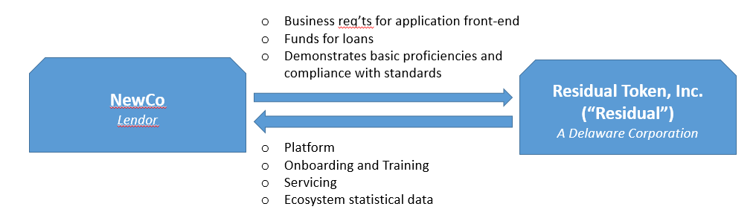Step 1: Lender and Residual Agree to an Open Services Agreement

Step 2: NewCo and Borrower

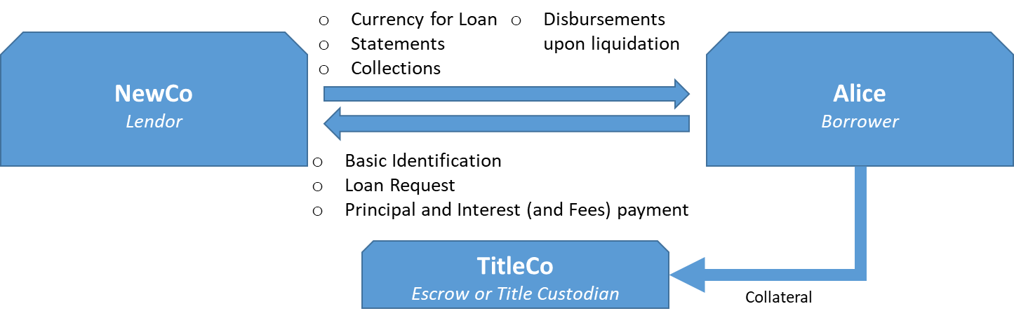

Residual will perform traditional loan servicing responsibilities; including, the transfer of loan proceeds from Lender to Borrower, processing of payments from Borrower to Lender and disposition of collateral/remittance of proceeds to appropriate party.

protocols.

Lenders, like NewCo, qualify for the Advanced Lending Toolkit®:

1. By owning a “license” token, hereafter called RSDL-L(ender);
2. Through decentralized voting process based on RSDL-L holder participation and/or through basic acceptance procedures earning the second key token, hereafter called RSDL-C(ompliant); and
3. Agreement around implementation of our protocols and acceptance of certain service guidelines.

Implementing our protocols is simple. In some cases it’s as simple as selecting a domain name and instructing our IT team how to mount access to the lending front-end. Our front end DApps using our protocols can be co-branded or exclusive to your organization. Borrowers pledge assets as collateral against currency of your choosing-based loans[7], accept terms and oblige themselves to those conditions or risk collateral forfeiture. Pledged collateral will remain in escrow/title agent custody for the duration of the loan and managed via smart contracts.

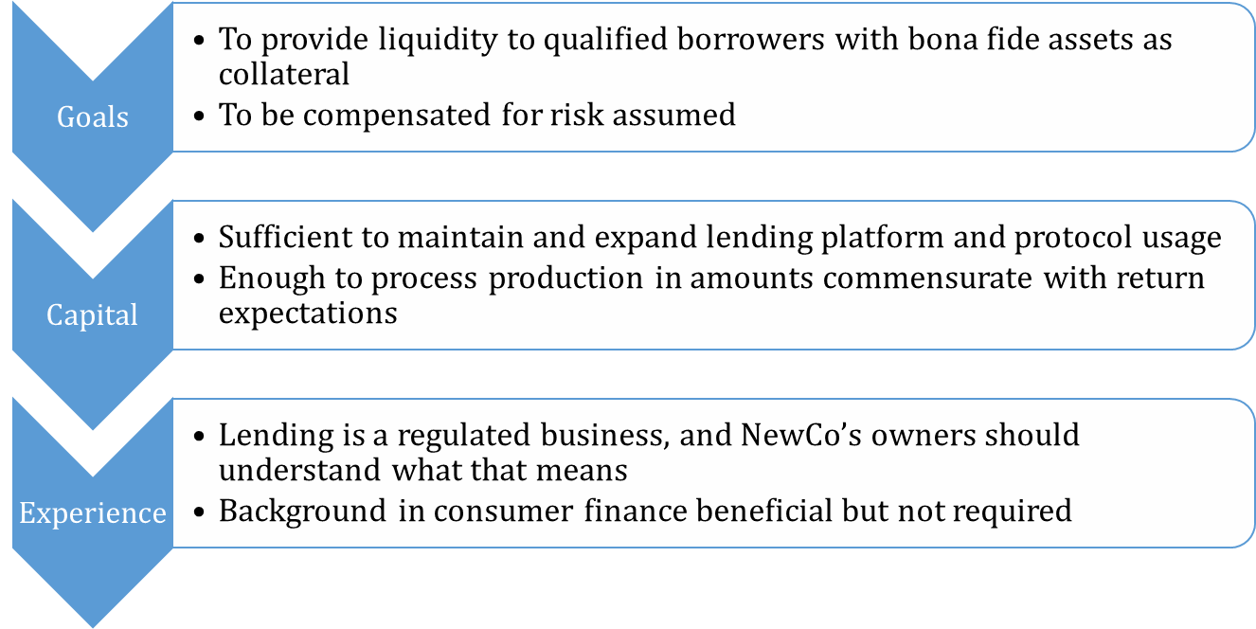**Diagram III: Generic Characteristics of Lender (“NewCo”)**

**Residual Token, Inc. (“Residual”)** is a registered Delaware corporation. Its Board consists solely of Founders and certain Advisors. In the spirit of supporting DAO initiatives, RSDL-L token holders will have the opportunity to vote on referenda related to Board representation, including the election of an observer position.

Residual is a large, minority owner of Proformance Management Group, LLC, a California company currently seeking a California Financing Law (CFL) license with the intent to be Residual’s first Lender.

Residual Token, Inc. will develop and implement protocols for NewCo to fit out its first collateral lending use cases. Residual provides training on protocol implementation and documentation for end users. Our plan is to have a SOC1/2 audit performed over the protocols at such time as sufficient volume is running through the ecosystem to warrant this attestation.

**Diagram IV: Typical Borrower Characteristics**

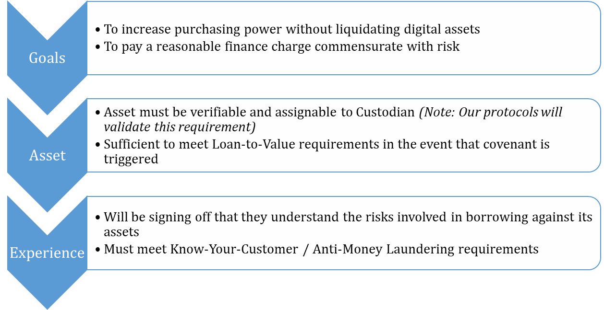

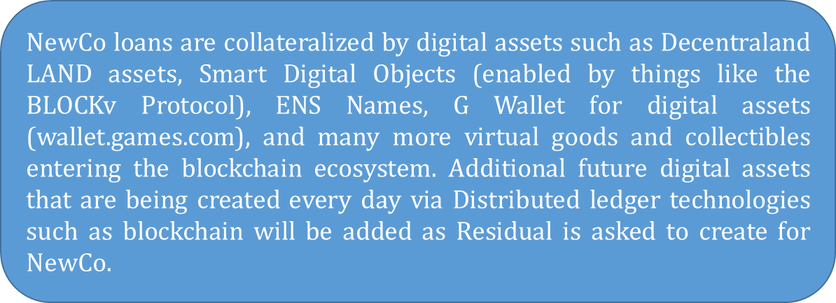Providing open source protocols will allow our closed ecosystem members, with a collective goal to improve liquidity and monetary velocity, to use these protocols to design their own set of lending parameters.

At first, protocols that best fit NewCo and like entities’ needs will be built, and we expect to see the protocols setup for future interoperability in a broader lending ecosystem. Residual will support and facilitate this growth. More assets are added to the environment daily and with those additions, there is increased demand for increased liquidity without sacrificing the underlying digital asset appreciation. Custom extensions using these protocols can be written to perform the same function for assets selected by the adopter.

# Build-Out Timeline and Token Sale

The following diagram lays out phased development and implementation approach.

**Diagram V: Phased Implementation Approach**

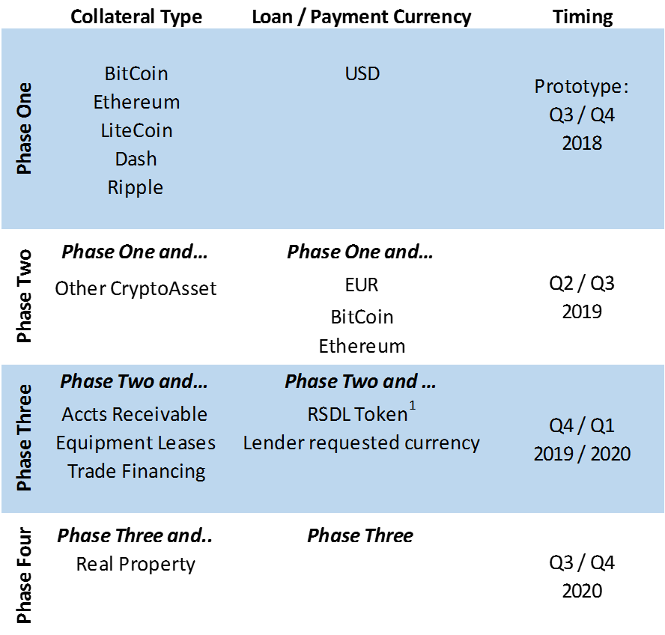

Residual may develop protocols to support lending against other assets even if no Lender have provided these services themselves by implementing the protocols on its own. Likely, this instruction would come from Residual once it determines sufficient demand for the illiquid asset exists.

It is our belief that by providing a set of trustless workflows to facilitate this type of lending, more holders of digital assets would be willing to invest more of these assets into more illiquid, tokenized assets and blockchain concepts. Thus, the platform accelerates innovation and use case development in this rapidly evolving economic ecosystem. Together, Residual users are bringing liquidity to an illiquid environment. We are creating monetary velocity where there currently is very little. When you create monetary velocity, you create value.

The RSDL-L(ender) token described herein is required to be held by participating Lenders in order to activate the protocols. Much like Certificates of Public Need (“CPNs”), for example taxi-cab medallions, only a finite number of these tokens will be produced. The RSDL-L token allows for certain voting rights, use of open source protocols, and myriad other rights and privileges.

Those interested in using the Advanced Lending Toolkit® will be required to stay in good standing with Residual Token, Inc. and the RSDL-L voting community as reflected by ownership of a non-fungible RSDL-C(ompliant) token awarded only to Lenders under strict voting procedures or assignment by Management. RSDL-C is non-transferable.

## The Token Sale

We intend to offer for sale a portion of the minted RSDL-L tokens. Our rationale for doing so is multi-faceted as stated below. The token sale will:

* Provide Founders data as to the validity of the overall concept;
* Act as an alternative source of capital for use in legal, build-out, marketing and talent acquisition/retention;
* Educate the market on the benefits and uses of a digital asset-backed lending system;
* Encourage early Lender entrants into the ecosystem; and
* Allow Residual Token, Inc. to monitor global preferences and interests.

RSDL-L will not come with attached rights or preferences beyond:

* Entitlement to a pro rata[8] distribution of certain proceeds collected from funded loans[9];
* Access to ecosystem data[10];
* Open source protocols usage; and,
* Policy & procedure manuals.

For those that wish to make loans, our open source protocols can be used and will operate with a single RSDL-L token. Anyone making loans needs to be compliant with local and federal lending rules and regulations[11]. For a more turnkey solution, a minimum quantity of RSDL-L tokens is one key in a two-key system required to activate the Advanced Lending Toolkit® protocols. A minimum amount of RSDL-L will be required beyond the holding of a single token. As of this printing the initial minimum will be 150,000 tokens per Lender. Changes to the minimum will be subject to vote by RSDL-L token holders that wish to participate[12].

Residual does not believe there is particular economic incentive to owning RSDL-L beyond its meeting a basic protocol usage pre-requisite. We cannot predict whether conditions would occur or not occur or what the risks associated with that condition occurring or not would imply about the perceived value of this token.

The token sale enables us to hire new talent, cover the cost for marketing/legal as well as for business and product development so that we can be the best digital asset-backed lending and (eventually) securitization platform available. Having enough runway to develop and try various workflows and technologies that work, are secure, and scale for this new space will be of utmost importance. Cautious spending of the token sale funds will be our guiding principle. One goal is to create a great experience for our token holders and Lenders. We will continually strive to meet that goal and revise our business model if feedback indicates that we are not meeting this objective. We welcome participation from our token holders.

### Allocation

Only 50,000,000 tokens are authorized for minting. We intend to mint all 50,000,000 RSDL-L tokens at once. Approximately 20,000 companies are recorded globally as providing some type of consumer finance. We have not developed in its entirety how various token aggregation levels relate to services allowed, functionality increase and/or production limits (i.e. geography, dollar volume, count, etc.)

The RSDL-L tokens will be authorized and issued in the following manner:

**20% (10,000,000)** with a soft cap is $2.5 million and hard cap of $10.5 million to be sold by Residual to private purchasers under the following conditions:



The purpose of the rounds is as follows:

* Private Sale (Phase I) – the intention is to use these funds to establish an off-shore presence and market Phase II;
* Private Sale (Phase II) – obtain capital to begin construction of base model in earnest and market to potential Lenders;
* Public Pre-Sale – fund operations, marketing and other budget items; and
* Public Sale – meet budgetary expectations.

The private sale will commence July 31, 2018. Each class will remain open until sold out. The amount of tokens sold in each round are based on Residual estimated capital requirements at various stages.

**46% (23,000,000)** reserved for the “Residual pool”. Usage will be to the discretion of the Founders once unlocked. Residual Pool tokens will be locked in an escrow account over a long timeframe detailed in the “Use of Residual Pool” section, limiting the ability of Residual Management to use funds other than for annual budgets, which will be unlocked each year.

**2% (1,000,000)** reserved by the Company to incentivize community, security via bounties, beta testers, marketing and strategic partners.

**17% (8,500,000)** to be distributed by the Company to the Residual Founders.

**15% (7,500,000)** to be distributed by the Company to the Residual Advisors. A portion of these tokens will go towards providing an incentive to the consultants and engineering team. Providing an incentive to the full team via tokens and is critical to the hiring, execution of tasks, and consistency of the team member pool.

#### Use of Residual Pool

The rationale behind structuring this liquidity platform on the RSDL-L token is in our belief that our lending, underwriting, servicing and collateral management protocols provide the best option to provide Borrowers liquidity, mitigate risk and provide reasonable Lender returns. RSDL-L is a vehicle to promote commerce, and it is supported by the collateral pledged and enterprise grade protocols. The protocols are designed by industry participants or those with expert levels of experience. We believe that the potential of digital asset technology will be realized by those who understand the specific risks and regulations associated with their area of specialization. While recreating the entire vertical is not impossible, the risks its exposes itself to are tremendous, and result in inefficient pricing.

It is the mission of Residual Token, Inc. to support its platform. The Residual company pool (“RCP”) will be used for two purposes:

* + 80 percent (19,000,000 tokens) will be to onboard Lenders, onboard participants or provide bonuses per the section above;
  + 20 percent (5,000,000 tokens) will be used for capital expenditures, SG&A and other sundry operations-related expenses; and
  + 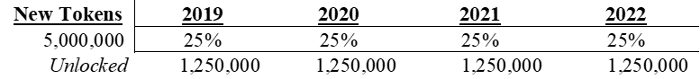Both pools will be locked up initially, releasing a little each year per the table below, respectively.
* 80 percent of the RCP will be used to shore up the business. Any unused sale proceeds will be held at Residual’s Chase Bank® account.
* 20 of RCP’s tokens will be used for the following as they are unlocked:
  + Capital Expenditures - to achieve the future state, a number of protocols will need to be developed. These protocols include securitization modules, hand-off protocols so others can launch lending platforms, and information systems for reporting (e.g. investor, management and regulatory.)
  + General and Administrative - Residual’s mission will require marketing RSDL-L to everyone so that they may experience the open source benefits, performing due diligence on digital assets (to increase the library of available virtual property), and meeting regulatory (i.e. Federal, State, Local and International) needs as they may arise.
  + Residual Token capability expansion - For Residual to expand its capabilities, some amount of investment will need to be made. More robust servicing capabilities decrease investor risk, increase pull-through on collections, and improve the platform’s robustness.
  + Talent acquisition - The Founders and Advisors are leaders in blockchain, digital assets and consumer lending. As Residual expands its capabilities, subject matter experts and global thought leaders will be required along with competent staff to deliver effective, innovative solutions to the marketplace. Identifying, screening, acquiring and retaining talent is the most important factor in our success.

#### Unsold Tokens & Team Vesting

* Any unsold tokens in pre-sale go into public sale.
* 100% of the Founders/Employee tokens will be unlocked over a period of approximately 36 months total. The team list may be updated during the 36 month vesting period.
* Advisor tokens are locked for 1-year following the first quarter from the grant date on a quarterly basis.

#### Private Sale

* Sale will begin July 31, 2018.
* Prices will be pegged to
  + $0.90 USD per token for Phase I
  + $.095 USD per token for Phase II[13]
* ETH prices will be pegged to USD based on the price of Ethereum listed on Coinmarketcap.com at 11:59pm EST on the night before the purchaser’s SAFT is received.
* Know-Your-Customer (“KYC”), including purchaser accreditation procedures where required, and Anti-Money Laundering (“AML”) processes will be completed by Buyer.
* SAFT countersigned and transaction considered complete upon receipt of funds; and
* We will notify various channels of the expected public crowdsale.
* Private sale purchasers’ tokens will vest accordingly:
  + Phase I pre-sale purchasers’ tokens will vest over 10 months following the token generation event;
  + Phase II pre-sale purchasers’ tokens will vest over 8 months following the token generation event;

#### PRE-SALE

#### Our pre-sale will coincide with two events:

* The token generation event; and
* Release of a working version of our combination of working lending protocols and manual processes capable of handling the commercial aspects of digital asset-backed lending.

Key considerations of the Pre-sale are as follows:

* Pre-sale tokens will be marketed for $1.15 per token.
* We expect to only run the pre-sale a few months ahead of a public crowdsale.[14]

#### Public Crowdsale

RSDL-L Tokens are intended to be sold as follows:

* Whitelist for Crowdsale must be complete by purchaser;
* KYC and AML processes to be completed by Buyer; and
* The exact listing price is $1.50 per token.

#### Crowdsale Start and End Date

Check the official website: www.residualtoken.com for further information.

#### How can I participate?

Fill out our Receive Updates form on the website. We will send you detailed info as the sale progresses.

Detailed instructions along with the contribution address will be posted on the official website: www.residualtoken.com

How are funds secured? All funds collected during the crowdsale will be deposited in a secure multi-sig wallet.

Keys will be held by Founders of Residual Token, Inc. making it so that all outgoing transactions have to be verified by multiple parties. The Crowdsale smart contract code on Residual's GitHub will be public and available for audit by anyone.

* Residual will seek a 3rd party audit prior to the Crowdsale start date;
* ETH exchange rates are subject to change without notice prior to the start of the public crowdsale. Once the public crowdsale starts the exchange rate will be locked; and
* The prices for the presale are not subject to change and will remain the same and have no effect on the public crowdsale.

#### Funding Allocation

All funds contributed in the Crowdsale will be used solely for the development, promotion, and growth of Residual ecosystem. Below is the preliminary allocation and the distribution and may be subject to change.

##### 50% Development

This refers to the development and operational costs of all technology described in this whitepaper, including smart contracts, wallets, SDKs, APIs, game plugins, third party plugins, and any other Residual Token-related updates. This will also cover hiring additional full-time developers and consultants to accelerate development so that we meet or exceed the roadmap goals and expansion goals.

##### 20% Marketing & Growth

The marketing budget allows for a constant and relentless promotion of Residual Token to Lenders in multiple target countries and lending segments. This will be used for video and other advertising, promotional events, sponsorships, mobile & social media ads, and to liaison with studios.

##### 5% Security

We are taking the necessary steps to ensure that optimal security standards are followed in every release. This includes professional code audits and penetration testing on all APIs, smart contracts, Mobile and PC wallets, plugins and SDKs.

##### 20% Legal

Residual will obtain the appropriate legal advice to always ensure that we operate in accordance with the laws and regulations of each jurisdiction that we do business in. Funds will be held in reserve for any future issues or challenges that may arise in any region.

##### 5% Hosting & Infrastructure

This will cover a minimum of 3 years of increased costs required for expansion of the web servers, firewalls, load balancers, DDOS protection and network for anticipated increases in Traffic to the web platform and public APIs.

# Tokenomics

The RSDL-L token affords many privileges, including the limited ability to participate in the development and execution of Residual’s business plan regardless of the number of tokens one holds. Further, a certain aggregation amount (“Minimum”) affords specific privileges; namely in conjunction with Residual’s permission, the Minimum allows access to Residual Token, Inc.’s protocols. The following table illustrates a number of open resources for all token holders and the limited features available to those wish to qualify as Lenders.

|  |  |  |
| --- | --- | --- |
| Feature | All Holders | Lenders |
| Available News, Updates, Articles | X |  |
| Open Forum Discussions | X |  |
| Access to Manuals, Policy and Procedure Guides | X |  |
| Source Code for Base Model | X |  |
| Access to Flowcharts, Presentations, etc. | X |  |
| Loan Performance Dashboard Information* | X |  |
| Lending Demographic Data[15] | X |  |
| On-chain Governance | X |  |
| Voting Rights[16] | X |  |
| Potential Committee Appointments[17] | X | X |
| Advanced Lending Toolkit |  | X |

PLEASE NOTE: That Lenders need the Minimum AND permission from Residual management (“Management”) (which may include, in some instances, public polling results) in order to use the Advanced Lending Toolkit protocols. A basic version of the lending platform and an accompanying manual will be made available for those who wish to start their own RSDL-L-based platform.

The Residual ecosystem, and thus the protocols, consist of a combination of decentralized public and private ledgers, centralized systems and manual processes. One of Residual’s goals is for the back-office and middle-office parts of the platform to operate largely autonomously. Overall, if the products created by Lenders and those using the basic toolkit are good loans, than the ecosystem will thrive. Competiveness as it relates to servicing, marketing, custody/title, and collateral disposition will only serve to make the pricing of products run through the platform better. The open source reporting and performance metrics will favor high quality ecosystem participants.

We established the price and quantity of the tokens based on the following assumptions and conditions:

* The number of potential system lenders is unknown
* The initial number of lenders is probably 4 or 5
* Initially we will have one service level (binary [e.g. you either have (X or more) or you have less than X]
* Entrants may enter at any time
  + Depending on the manner with which they enter the system, token holders may be subject to lock-up periods
  + For instance,
    - Founders/Employees: 3-year token lockup from acquired date
    - Advisors: 1-year lockup starting one-quarter after acquired date
    - Lenders: 3-year lockup from acquired date
    - Residual Token, Inc: Various not to exceed 7 years depending on how tokens are earmarked for use going forward
* Exiters may exit at any time
* Additional Tokens will not be created and no tokens will be destroyed once minted

Please Note: That as it relates to the actual sale of RSDL-L tokens, Management will consider holding a Dutch auction for 500,000 of the 10,000,000 tokens intended for sale.

The protocols governing access would be able to have the following information in verifying a Lender and a service level:

* Amount of tokens held by a Lender
* The purchase timing and average price paid by the Lender for his tokens
* Market Value currently of the Lenders tokens
* The price paid by the last verified Lender (indicated by a separate token type provided by Residual)
* Count of Lenders (using our token)
* All the above factors for all lenders (e.g. timing, cost basis, fmv, quantity)
* Total minted tokens
* Total available to be minted tokens
* Current required Minimum (defined below) tokens

### Distribution to RSDL-L Holders

As an incentive to hold RSDL-L tokens and for a limited time, Residual Token, Inc. intends to distribute a portion of proceeds earned and collected by the Company to token holders. As discussed elsewhere in this document, part of Residual’s revenue model includes collecting a nominal fee for each funded loan using the Advanced Lending Toolkit®.

We cannot guarantee that programmers will use our open source protocol versions and bypass this feature of the platform. In such cases, Residual may not collect any fee related income on those loans generated on our system.

For those funded loans where Residual collects a platform usage fee (currently 50 basis points collected at the funding of the loan), 10 percent of the usage fees collected will be pooled. After tax, operational expenses and other fees associated with this pool are paid, the remainder will be distributed on a quarterly basis to all token holders accept those tokens being held by Residual. The platform usage fee may change time-to-time as determined by a combination of RSLD-L token holders, Residual management or Board members. This program will cease at point in time determined by Residual management and purchasers of the RSDL-L token should consider this when making a purchase or sale decision.

## Findings

There are two issues contemplated here:

1. One, the Minimum at the token sale date, and subsequent dates; and,
2. Two, voting rights.

The following sections contain information related to the PROPOSED governance of the Residual ecosystem. Actual functions, parameters and descriptions related the Residual ecosystem, Residual Token, Inc., and RSDL-L (or other digital assets produced or contemplated by Residual) are subject to change.

### The Minimum

1. Develop an OR-based requirement for the business. Minimum will consist of:
   1. A fixed number of tokens (X), or
   2. A set percentage (Y%) of all issued tokens
   3. **Note:** As of the writing of this memo, at issuance these two will be the same number (I.e.  X = Y% * Total number of tokens minted), or
   4. Minimum = 150,000 tokens or 0.3% of the 50,000,000 tokens minted
2. Management or token holders, subject to the 3% ownership of then circulating and voting RSDL-L referendum threshold and in a manner consistent with the one described in the Voting Rights section below, may put forth for vote a new Minimum:
   1. Token holders elect to change the Minimum
   2. Presumably, New X = New Y% * Total number of tokens outstanding, but this is not a requirement
   3. Changes will go into effect a minimum of 60 days after the change is approved or on a date selected by the token holders not be less than 60 days or greater than 120 days.
3. Selected Minimum options to be eligible for vote by token holders will be based on market conditions and must respect Management’s fiduciary responsibility to existing debt and equity holders.

### Voting Rights

1. RSDL-L token holders will have **voter rights** with limited privileges;
   1. Unlocked token holders must elect to lock their tokens for a period of 1-year to vote
   2. One token, one vote
   3. Any tokens held by Residual Token, Inc. are considered abstentions and not factored in the totals counted
   4. Generally will be able to vote on issues. For instance, under varying circumstances or through aggregation of a enough tokens to float a referendum, token holders may elect[18];
      1. Members of the board of directors,
      2. Changes to the Minimum
      3. The onboarding of a new Lender, and
      4. The establishment of corporate objectives and policy.
2. A super-majority, which as of the writing of this memo is **60%** of the circulating tokens, is necessary to pass any referendum;

### Certificates of Public Need – An Anology

The RSDL-L Minimum is akin to a taxi-cab medallion or other type of Certificate of Public Necessity (CPN); meaning, that in order for a Lender to operate the Advanced Lending Toolkit protocols each must maintain a defined quantity of the token. If a taxi-cab company wishes to make money ferrying passengers, its drivers and vehicles must be licensed and registered respectively. Similarly, Lenders wishing to use the platform must obtain a permission from Management (or in certain cases other token holders as described in the Voting section above). The combination of this permission and Minimum allows the Lender to make loans through the Company’s platform. The basic lending platform software is available, and we encourage market participants to leverage that software for their own RSDL-L-based lending system.

There is an active market for CPN speculators, and we suspect the same behavior will be present in our ecosystem. The token value, of which Residual is agnostic, will be most correlated to the performance of the people and entities using the platform, the entry demand from additional Lenders, the Minimum and the supply of RSDL-L.

Based on our first-year budgetary requirements and the amount of tokens being sold we estimated a price around $1.20 per token. This token price, assuming 150,000 tokens are needed to be a Lender demonstrates consistency with the costs of other enterprise software solutions. Take for instance financial services firms that use Bloomberg®, Thomson Reuters® or S&P Capital IQ® for market data. These platforms run on annual subscription for anywhere from $50,000 to $100,000 depending on the number and type of licenses and features. Moody’s RiskCalc®, and product technology software may easily run in this price range. If a Lender were to buy RSDL-L on the open market at $1.50/token, then the out-of-pocket would be about $180,000. Were one to assume that life on the platform is 2 to 3 years (and hopefully more), then the software costs similarly range from $50,000 to $75,000 per year.

The per token price can vary substantially based on a variety of external and internal factors on the run. For instance, should the regulatory environment prohibit the existence of these instruments or Residual is unable to deliver a platform consistent with market expectations, the value of the token could easily be $0. However, should non-Lender demand or Lender demand exceed expectations, then the 50,000,000 tokens originally contemplated will be absorbed by this population and cause the perceived value of the token to rise. Token purchasers should have no expectation of profit, and instead make the decision based on whether the features afforded RSDL-L holders make sense to them, personally or from a business perspective.

#### Economic Theory

Melcalfe’s Law: n x (n-1) = n2 – n the value of the network goes up as the square of the number of users. This is an indication or rule of thumb as opposed to a law. If 10 people use a network, its value is 100, but 100 people use the system then its value will be 10,000. This graph illustrates this behavior for Bitcoin wallets relative to a lognormal growth chart in market capitalization:

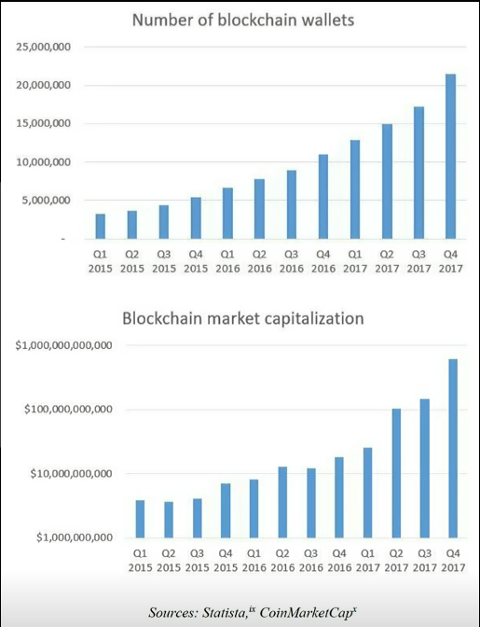Graph I: Blockchain Market Capitalization and Number of Wallets



In the case of Residual, we would consider the number of Lenders on the ecosystem the true driver of value for the RSDL-L token, as non-lenders will not be able to generate earnings using the lending protocols. If there is reduced risk resulting from a vetted system, more accepting marketplace and additional digital assets available as collateral, access to the platform becomes more valuable. It is not the intention of Residual to focus on the absolute value of the RSDL-L token, but rather provide robust protocols and support the participation of as many Lenders is possible in consideration of the limited number of tokens minted.

# Open Source Concept

Residual fosters innovation and creativity. The limits of Residual’s application in specialty finance are defined by the programmers’ imagination.

Qualifying companies may use Residual and its protocols to define and expand its own digital asset-backed lending program. This expandability is Residual’s key value proposition; namely, as distributed lending networks expand its secure lending portfolios and adds liquidity to the system, more adopters means greater innovation scaling and lower lender costs. Residual has an economic incentive to evolve the platform and protocols to increase its value. Residual may provide consulting services to protocol developers or Lenders looking to optimize their processes. Additionally, Residual receives a nominal transaction fee triggered by loan funding, loan payoffs and collateral disposition. These transaction amounts are proxy licensing fees and not significant relative to the Lender’s return in the vast majority of instances.

Residual will create open source, customizable extensions of the protocols driven by the commonly accepted digital assets. The protocols developed may be bolt-ons to the existing platform or may be wholly new and separate applications. We support creativity and as Residual’s mission is to maintain and enhance the value of ecosystem.

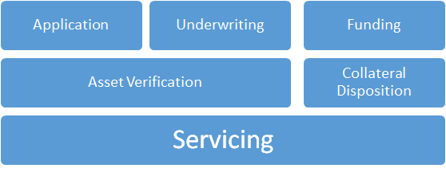**Diagram VI: Protocol Architecture**

## Our Competitive Advantage

The lending model, diagrammed below, illustrates how our simplified, comprehensive due diligence platform allows Borrowers quick access to any currency and how the platform can evolve based on the quickly changing needs of the digital asset lending market.

Appended to this document is a draft technical mapping of the mortgage origination and servicing platform provided through a strategic partnership with one of our Advisor’s companies and our mapping of the major decentralized components.

**Diagram VII: Borrowing Cycle – Application to Fund**

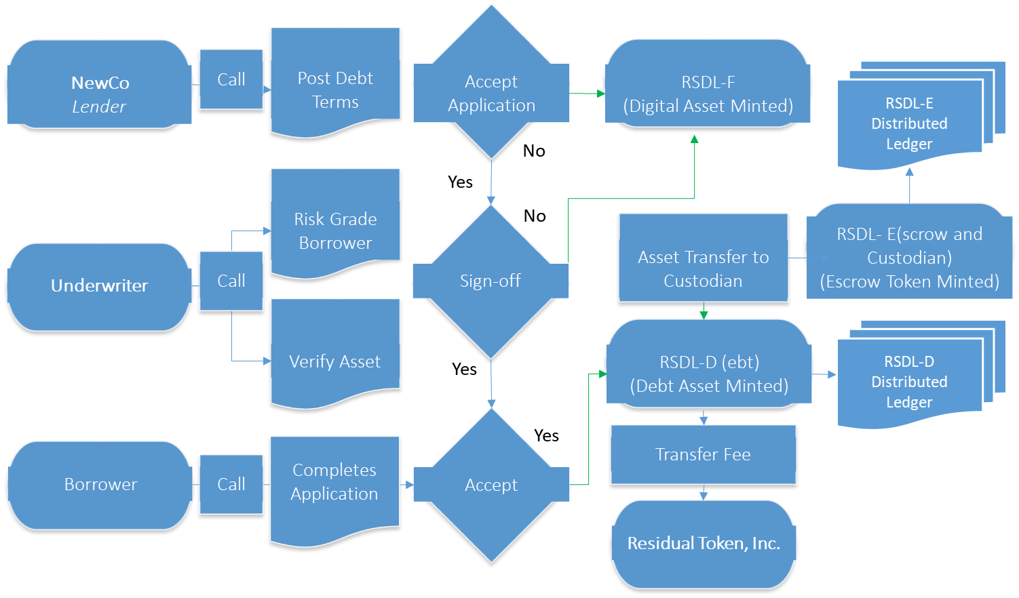

**Diagram VIII: Borrowing Cycle - Payments**

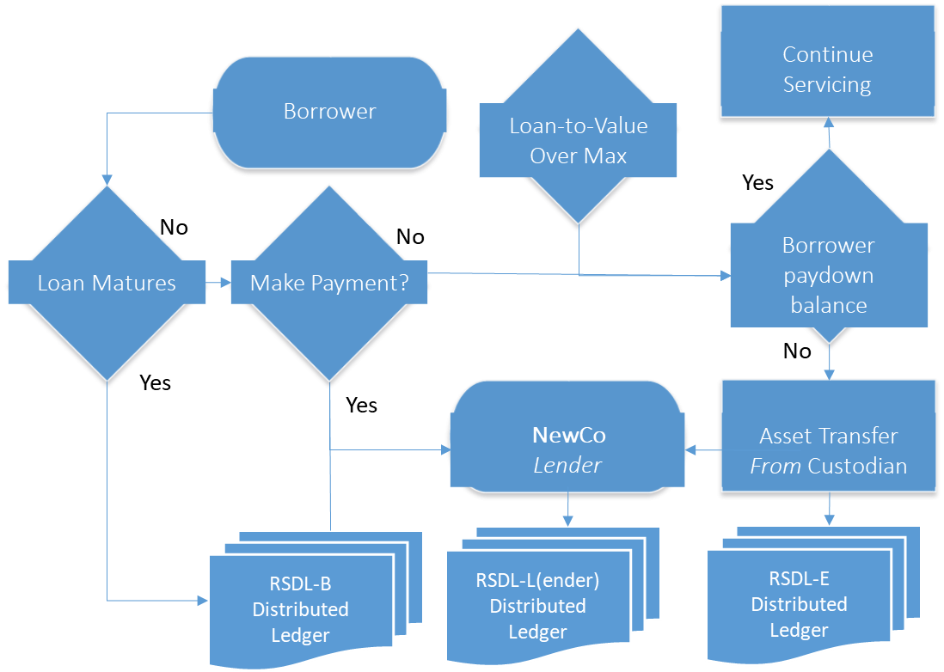

**Diagram IX: Borrowing Cycle – Collateral Disposition**

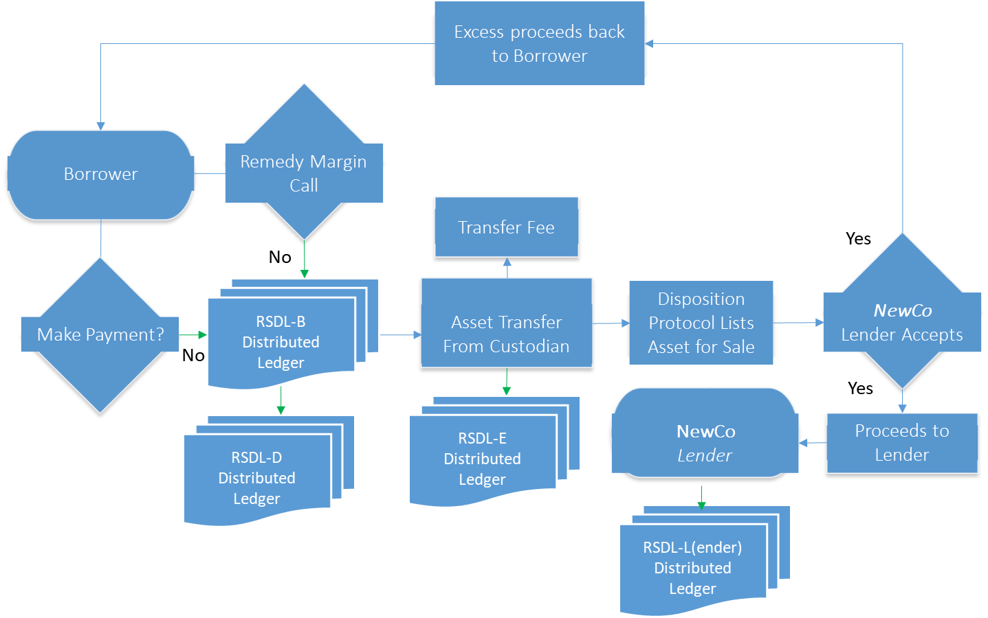

The Founders and Advisors have been in specialty finance, consumer and commercial lending in aggregate for over 100 years. A few key lending principles include:

* Accurately assessing the borrower’s willingness and ability to pay;
* Estimating the probability of default and likelihood of recovery;
* Responsible and appropriate collection practices;
* Mechanisms for regress and addressing grievances;
* Structuring and Pricing loans such that:
  + Pull-through and funding are competitive;
  + The risks in the first two bullets are adequately covered;
  + Servicing and borrowing costs are covered; and
  + Investors are compensated for their risk.

Our collateralized lending protocols draw on lending concepts documented by Frank Fabozzi, and the principles of loss and recovery captured by Hull-White’s Risk Neutral Probability Default papers.[19][20]

Peer-to-peer lending brings with it the risk of collapse due to poor underwriting. Having professional, experienced lenders and credit risk management protocols in place allows for competitive, risk-based pricing and more efficient production throughput.

**Diagram X: Ongoing Residual and NewCo Relationship**

Lender Newco

#2

Fiat payment

**Residual**

**Protocol Development**

Protocol A

Protocol B

Protocol C

Fiat payment

Protocol A

Protocol B

Protocol C

Lender Newco

#1

# An Abridged Origin of Currency[21]

Either as a result of our nature or our ability to generate profit from reducing inefficiencies, humans have evolved various forms of exchange throughout the millennia. According to various sources, most early economies were based on debt and gifting. Bartering as a method of exchange was likely limited to scenarios where the parties to the transaction either met infrequently or potential combatants in the future. The earliest money was set equal to some amount of an agricultural good and could be used in exchange for certain commodities. This makes sense because it's hard to imagine a society where groups of individuals come to a central meeting spot with wagon-loads of their families’ products in an effort to swap out one good for another. Money becoming a form of exchange makes sense, but its ‘value’ is a little trickier. The system of fiat currency at various times backed by gold or silver, or both or none, and the government’s that sponsor the currency has evolved to a point where people expect another currency exists to back the currency they hold. Just ask someone if they’d accept a dollar from your pocket in exchange for a dollar from theirs to test this theory.

According to the World Bank, the GDP in the U.S in 2016 was approximately $18.5 trillion dollars. According to the New York Federal Reserve Bank, $1.2 trillion dollars is in actual circulation. While the GDP measures transaction volume, it would be impossible for the $1.2mn hard currency to be involved in the $18.5 trillion in transactions annually. Society has become reliant on credit, ledgers and means other than hard currency to transact. According to once article, about 11 percent of transactions are made using actual hard currency[22], and the majority of transactions occur online with stored credit card data or purchase with a credit card at a live retailer.

Digital assets and trustless ledger systems are the natural extension in our monetary evolution. Much like early currencies were tied to specific measures of a commodity to remove the need to ‘trust’ the value of the currency would be there in the future, trustless distributed ledgers provide equal transparency. The reliance on government backing a currency or other appeal to authority stems from a trust-necessary system. Ours is trustless.

Our platform, a set of modular economic protocols, mimic a multi-millennia old system of providing debt to add liquidity to a system. We start with a simple lending model, and encourage programmers to develop customized economic modules. In time, a distributed system of spoke and hub micro-economies on the platform will arise addressing the local micro-economic needs of the economies where the customized protocol systems serve.

## Founders

Howard and Ryan met while both involved in the financial industry in the Charlotte, North Carolina area and have known each other in a professional capacity for almost 16 years.

### Howard Krieger

Howard is a Managing Director in CBIZ Valuation Group, LLC (“CBIZ”). He specializes in the valuation of complex financial instruments including digital asset loans, interest rate swaps, agency and non-agency mortgage-backed securities (MBS), and collateralized debt obligations (CDOs). He is a former Big-4 Senior Manager responsible for a variety of assignments including: intangible business valuation, intellectual property valuation, financial modeling, valuation of equity participating instruments and other exotic financial assets/liabilities with almost 20 years’ experience. Howard has an MBA from Rutgers Business School with a concentration in Quantitative Finance.

### Ryan Medlin

Ryan Medlin is a seasoned Silicon Valley entrepreneur and technologist. His most recent exit was the sale of his proximity tracking and measurement company Datasnap.io in 2015 to Neustar where he then led a team of engineers to build out Neustar's IoT Identity initiatives. This included a product for IoT which was an improvement over normal PKI providing cryptography based policy enforcement and Identity Management in a highly distributed architecture. As part of this responsibility for the past 2 years, many Blockchain and DLT based prototypes and concepts were given a lot of resources and review. Platforms and protocols included: IoTA, Ethereum, Hyperledger, Rootstock, Lisk, NEO and many lower level protocols including things such as Telehash, Cothority, and Dfinity.

His previous experience was building financial systems for large financial companies while working for Accenture in the Charlotte, NC area and he also provided independent consulting expertise for companies such as Well Fargo Securities (formerly Wachovia Securities).

### Key Advisors (Alphabetically Listed)

Alan Alford, PhD – International Business (*Economics and Risk Management)*

Katy Atkinson – Product Development

Scott Banks - Middle Office / Back Office Treasury and Operations

Melissa Barbera – Legal Strategy

Edward Eaton - Front Office / Middle Office - Lending Operations

Michael Forester - Compliance

Michael Gale – International Tax

Stanley Krieger - IT System Test

Dan Love - Operations

John Owens – Front Office / Compliance

Trey Rawles – ICO Consultant

Rosslyn Smith – Project Manager

Kumar Sriram – Information Technology, Encryption, Blockchain

Kevin Thompson – Business Development

Martin Williams – Loan Origination Architecture / Front Office

### Future Engineering Team

Ryan has been building teams of engineers for his own and various startups for 11 years in Silicon Valley and has some of the top engineers in the area (and remote) very interested in joining pending successful funding. Also a set of top talent off-shore teams are being on-boarded as well pending funding.

# Statutory Lending Laws and Compliance

It is our opinion that while regulations around digital asset-backed lending have not been explicitly codified by the Office of the Comptroller of the Currency (“OCC”) or other government agency, all protocols must comply with existing fiat currency lending regulations. Residual will **NOT** be responsible for protocol users obtaining or maintaining required licensure. However, we can document how its existing documentation maps to the protocol framework. Customized reporting designed to support your existing lending compliance procedures, and MIS consistent with other product in-place KYC and KPI reporting.

NewCo, a licensed Lender in California, integrates required AML and KYC protocols to meet state and federal lending rules. Residual is available to provide integration advice, reporting and custom protocol development.

Our statutory compliance is not limited to lending laws. We strictly adhere to securities’ laws and guidance set forth by the SEC, IRS, CFTC, CFPB and any number of federal and state agency with a vested interest in the future of digital assets. We welcome any opportunity to work with or comment on behalf of industry participants in developing these principles, best practices, recommendations, regulations or laws.

# Know Your Customer and Anti-Money Laundering Compliance

Our Know Your Customer (“KYC”) process applies to both borrowers and currency aggregators. We cannot enforce our protocol users’ adherence to relevant regulations. We intend to strictly adhere to the rules and regulations governing KYC/AML processes in the countries of incorporation. The immediate population upon which KYC monitoring matters are critical are the Borrowers. Residual will use commercially available verification protocols to support KYC/AML requirements for our Lenders’ borrowers. Lenders ultimately bear the responsibility for vetting customers and maintaining appropriate levels of licensure.

Borrowers provide information in a quick and intuitive click-through process requiring minimal input, no document uploads and leveraging standard eSignature protocols.

NewCo’s protocols are accessed through its web portal (or operated by a call center) overlay on its custom web background. Borrowers see allowed assets, asset verification submission forms, and other data available sourced from other platforms or custom protocols.

Due diligence protocols may consist of the following:

* Capture borrower name and address;
* Verify borrower existence;
* No credit check, but must meet the following criteria:
  + Must be 18 years old;
  + Must have a U.S. bank account;
  + Provide proof of regular monthly income;
  + A verified mobile phone number;
  + Affirmation that no large personal loans outstanding; and
  + Affirmation that the collateral being pledged is theirs to pledge (ie. clean effective title).
* Verify collateral existence.

Once the borrower is verified, he or she agrees to the terms and conditions of the loan via eSignature and mandatory scroll-through logic. Contract terms are preferred by attorneys from an international, reputable firm in both the digital asset and consumer lending industries. Tokens are minted for the verified borrower, and the debt.

The programming logic of the contracts seamlessly mirrors the legal terms and conditions from the loan agreement and written using established logic. Digital integration, backwards compatibility and interglobal connectivity are all hallmarks of our developers.

# Borrower Considerations

Borrowers pay back their loans in the contractually established fiat or digital assets. Customary loan-to-value protections against offsetting or combined value changes resulting in greater than same percent disparity from loan origination date values exists in our ecosystem. This structure has many benefits to both Borrower and Lender, and is described further in the Loan Payback section below. We also explore worst-case scenario impact on the loan’s value, and methods for hedging the risk further in this white paper.

Borrower’s payback to NewCo can be automated via a scheduling contract via ethereum-alarm-clock for the ethereum implementation then moving to the Zen Protocol scheduler as appropriate (see Ethereum to Zen Protocol transition section).

The Residual Token, Inc.’s protocols include those defining the structuring, underwriting, funding, servicing and payment processing workflows using the platform based on NewCo’s initial needs.

We want other entities to use the platform and protocols to define components of its NewCo services. It is important NewCo fit up its particular financial use case and run the decentralized network platform protocols.

The protocols will be open source, however, Residual will monitor transactions and participants that do not meet the mission of maintaining and enhancing a fair and transparent ecosystem. Our RSDL-B and RSDL-C tokens will represent ratings as such to be taken into consideration on a case by case basis. However, beyond this requirement, the Residual platform provides freedom of choice, transparency, and good decentralization logic for the singular purpose of increasing monetary velocity.

To combat the risk associated with collateral value drops, our protocols include capital calls in the event loan-to-value falls below a pre-programmed limit.

Below that limit, the Borrower can meet the capital call by paying down principal to NewCo, or NewCo will sell what it can of the asset to get the loan-to-value back in line with the contract terms. If the asset is indivisible, the collateral will be liquidated in its totality with excess proceeds being returned to the Borrower.

*Over-collateralization*: NewCo sets loan-to-value at 70 percent. Borrower places $15,000 worth of digital currency in escrow, and receives $10,500 in loan proceeds. If the Loan Amount-to-digital asset value rises, Borrower is required to paydown principal within 24 hours of the infringement to maintain this ratio or better throughout the life of the loan. Failure to remedy results in the digital asset being surrendered to NewCo.

# Management Services Implementation

Ongoing management services for the NewCo entity population include developing, enhancing and maintaining protocols for application processing, loan pricing, loan servicing, key performance indicator (“KPI”) reporting, collections, portfolio management and general administration. RSDL-L holders, regardless of token aggregation amounts, will have access to system data subject to privacy and copyright restrictions.

The entire structure is managed through the open architecture and underwritten using established, well-credentialed pay-for-play vendors operating on a robust, secure architecture.

# Fee Structure

Supported digital assets or fiat will be used to pay fees for each smart contract execution looming very much like the per API call pricing that cloud providers use today. In the future holders of the Residual-issued (“RSDL”) currency tokens will incur deep discounts for these fees since keeping a consistent currency during the debt lifecycle simplifies the ecosystem and therefore the cost to maintain and monitor accordingly.

Open source protocols allow NewCo entities to augment its unique platform with other origination fees, service charges, holding and disposition expenses. As required by law, we recommend NewCo understand compliance related limitations pertaining to fees, asset custodianship, asset possession, disposition and borrower reimbursement. Residual, and their affiliates will not be responsible for compliance with local, state, federal and international regulations.

# Residual Tokens – RSDL Derivatives

One future state includes the creation of a unique currency token for our platform (“RSDL”). The token along with the protocols will continue to provide liquidity to holders of illiquid assets. In exchange for providing this platform, Borrowers pay Lender-established market rates, and obligate themselves to the terms of loans offered by the Lenders.

For instance, prepayment may be allowed, and capital calls may be in-place to act as credit enhancement.

Residual will be committed to protecting RSDL to foster a healthy and broad digital asset-backed lending ecosystem, encourage innovation and be a conduit for others to set up localized lending platforms.

## PLATFORM to INCENTIVIZE COMMUNITY

Borrowers have been cut off from certain avenues because of restrictions put in place by regulators. Lenders have similarly faced higher costs of capital or specific covenants preventing lending to certain restricted classes. As a result lenders have faced margin compression, and borrowers have faced higher funding costs disproportionate to actual observed defaults. Residual lowers barriers to capital to qualified borrowers, and provides a profit incentive for lenders already tooled to originate, fund, service and portfolio loans.

## RSDL-D To Represent THE DEBT ASSETS

A class of RSDL (“RSDL-D”) are non-fungible tokens and will represent the Debt assets themselves once accepted by all parties needed and value exchanges represented by the debt asset. This is the tokenization of Debt and the use/promotion of this protocol as a standard with be of utmost importance of Residual Token, Inc. We will keep the delta between emerging debt token protocols such at the Dharma Protocol as small as possible where it makes sense to further ease future integrations.

This token will be critical to managing the Residual Token, Inc. usage fee generation. Residual charges a fee for each funded loan (e.g. RSDL-D) token minted. 5 basis points for each RSDL-D minted dollar will be aggregated and distributed quarterly to RSDL-L holders on a pro rata basis of non Residual owned tokens.

## RSDL-U To Represent UNFUNDED LOANS

A class of RSDL (“RSDL-U”) are non-fungible tokens and will be used to track loans where the applicant does not accept the terms of the approved loan. An extension of RDSL-D.

## RSDL-F To Represent FAILED LOANS

A class of RSDL (“RSDL-F”) are non-fungible tokens and will be used to track loans where either the Lender or the Underwriter failed the applicant’s request. The cause of the failure will be included in the blockchain to allow for behavior tracking, intelligent learning and other reporting or processing needs. An extention of RDSL-D.

## RSDL-E To Represent ESCROW/TITLE AGENT ASSETS

A class of RSDL (“RSDL-E”) are non-fungible tokens and will be used to manage the escrowing/custody transfer of assets from the Borrower to a neutral account. The RSDL-E token will be used to run the escrow/title agent protocols, generate data to measure transfer accuracy and efficiency, and serve as a critical element in Borrower and Lender confidence.

## RSDL-B To Represent BORROWERS

A class of RSDL (“RSDL-B”) are non-fungible tokens and will be used to represent the reputation of a Borrower ecosystem participant based on attributes and behaviors in the ecosystem such as repayment history and various other activity metrics. These cannot be transferred to another identity in the system. Right now the identity is represented by an ETH/RSDL address however in the future working to map to more proper higher level identities such as Civic, uPort, and other identity ecosystems will be integrated. Our protocols will abstract away this notion of identity in order to make this ability future proof as the Decentralized identity ecosystem evolves.

## RSDL-R To Represent LENDERS

A class of RSDL (“RSDL-R”) are non-fungible tokens and will be used to represent the reputation of a Lender ecosystem participant based on attributes and behaviors in the ecosystem such as funding history and various other activity metrics. These cannot be transferred to another identity in the system, and holding is one prerequisite of the Lender in order to operate the protocols. Right now the identity is represented by an ETH/RSDL address however in the future working to map to more proper higher level identities such as Civic, uPort, and other identity ecosystems will be integrated. Our protocols will abstract away this notion of identity in order to make this ability future proof as the Decentralized identity ecosystem evolves.

RSDL-C will be minted by Residual and provided to compliant Lenders. The combination of RSDL-C and a certain aggregation amount of RSDL-L are required to run the Advanced Lending Toolkit® protocols. A basic model, manual policy documentation and other information will be provided to anyone holding a single RSDL-L token.

Lenders also benefit from being party of our network more generally. Market intelligence, customized reporting, marketing support are just a few examples our platform offers. Akin to other professional lending international organizations, we think the ecosystem will very quickly settle on a price/risk relationship by varying asset class, and as an organization participants will share thought leadership on how to optimize that relationship. With over $14T is asset types to potentially mount on our platform, there will certainly be a lot to speak about.

# Technical Overview

A more detailed technical white paper as protocols and backend systems needed to facilitate reporting and other back office workflows will be maintained ongoing as they are developed so that they can be properly evaluated for proper decentralization, privacy, and security.

## Key Tenets of Residuals Technical Design and Implementation

* Facilitate evolution of the system via clean protocols and adapters;
* Decentralization and transparency while maintaining privacy in every area of the ecosystem;
* Initially, loan proceeds and payments will be made in fiat currency, backed by digital assets. There will be no primary token used in the Core Protocols. Other Currencies may be used where appropriate, until RSDL tokens, should Residual decide to mint, are made primary through voting procedures;
* Each Protocol is fully decoupled and could potentially be used in other ecosystems independent of each other;
* Security of the protocol contracts and overall system is of utmost importance; and
* Transparency of transactions for third party review while maintaining privacy of actors is a MUST.

## Importance of Decentralization

Decentralization removes intermediaries and their incentive to control a market and therefore introduce pricing only advantageous to themselves in in worst case manipulate markets and take advantage of consumers by lack of transparency.

It will also promote fairness across all individuals in the ecosystem regardless of geographic location or current economic status.

## Ethereum Platform

The first iteration of the Residual platform will be built on top of the Ethereum Network and Smart Contracts. It goes without saying that this is the leading smart contract platform and most of the asset based tokens are currently represented here. We will leave the benefits to using this platform to the other articles and website out there available and respected by the digital asset industry and try not to make the case here.

The NEO platform is a close second so working with that platform will come later in the roadmap and we will always be looking at how to work with those assets classes on various blockchain platforms to bring them into the Residual ecosystem. The use of Atomic swap and related technologies may prove critical here in the future.

## Security

The security of the contracts themselves will continuously be improved via third party reviews, operational security, and continuous audit of our blockchain transactions. Open sourcing all protocol code and dApp code will also ensure the community at large can review the security and we will provide bug bounty rewards of RSDL to incentivize further review.

## The RSDL Protocols

The protocol chain is diagrammed roughly as follows.

These protocols can be used as the basis of building various DaPPs needed to facilitate the various lending workflows outlined in this document such as for our initial decentralized lending DaPP.

**Diagram XI: Protocol Chain**

Asset Verification

Borrower Application

Collateral Disposal

Loan Pricing

Borrower Acceptance

Funding / Escrow

Loan Servicing

Back Office

Front Office

Middle Office

Collateral Valuation

Internal Reporting

### Asset Verification

As new asset class types are reviewed the foundation will review and potentially facilitate the creation of Asset Class protocol representations into the Residual ecosystem to unlock liquidity via our platform for those asset types. The below assets types will be represented in our initial roadmap.

#### Asset Class Types

##### Bitcoin

We will provide easy documentation to convert any number of these currencies to any form of asset token allowed on our platform. It is imperative our protocols are represented on the bitcoin network due to its market leadership position and overall age and security and censorship resistance.

##### Altcoins

Coins backed by their own blockchain and consensus algorithms.

Some of these re:

* Bitcoin Cash
* Litecoin
* NEO
* Zen Protocol

They have various purposes and fit better to certain use cases.

We will of provide additional documentation to convert any number of these currencies to platform-ready token types allowed for loan borrowing/servicing as well as providing Cross-chain atomic swap capability that would be very important to bringing in third party tokens into the Residual ecosystem.

##### ERC-20 tokens

Our platform allows for running on top of Ethereum. It has the widest range of smart contract expertise and tools and best practices in order to build out our own smart contracts.

Many companies are realizing its own asset class on top of this standard and therefore if we get our own protocols right we will immediately enable any new asset tokens using this standard almost immediately.

##### ENS Names

There is currently more than 50 million ETH locked up via contract holding ENS Names. Companies such as Residual are currently designing lending around this type of asset class and there is no reason why we cannot support this type of asset class as well.

##### Non Fungible Tokens (Distinguishable digital assets)

These classes are our leading dApp and the initial problem our platform will to solve; to improve the velocity in the digital asset ecosystem pertaining to these types of assets. This also allows for the leveraging up of positions in a particular digital asset. We predict the market for the non-fungible token type of asset will grow into the billions based on current valuation of assets such as Decentraland LAND, video games with digital assets such as Crypto-kitties and TRX Dogs.

“Tens of millions in USD equivalent have been spent on crypto collectibles at an accelerating rate, with most of these transactions occurring in just the past few months, resulting in significant media coverage.”[23]

The evolution of the ERC721 standard is of critical importance here. Our team has purchased LAND via the Decentraland auction mentioned in the above blog post and even closely monitored the conversion of to those held LAND assets over the new standard. Closely watching the evolution to this standard in the contract code was invaluable to the design of the protocols in this document as it relates to assets.

### Borrower Application Processing Protocol

Our protocols provide rapid response FAQ and in-process feedback developed from years of experience on a cutting-edge, AI platform. Our goal is to allow NewCo entities to quickly capture borrower data and execute funding in a manner that allows borrowers same day access to funds. Upon completion of the various data integrity checks, if accepted, our protocols generate the rate offering. User acceptance of the terms and conditions set by NewCo via its protocols triggers the funding and servicing protocols.

The borrower protocol is designed to quickly capture the relevant KYC/AML data custom to the NewCo’s requirements. The front-end is designed using best practice data aggregation tools, and can be designed to sit on top of the existing lender’s GUI. The key information is not only fed through the Decision Engine, but also establishes a user account. In doing so, we can actively monitor, solicit and inform the borrower on a variety of key topics related to the existing loan, observations around the digital assets value and other product offerings.

Upon passing our borrowing protocols, our asset escrow/custody protocol and lending protocols engage. The Borrower protocol handles the wind-down of the application process regardless as to whether the result is favorable or unfavorable to the Borrower. The Lender always has discretion to manually intervene in the loan funding process, even in the event that pre-established approval criteria have been met.

Checkbox and eSignature capture occurs in this part of the process, and is built around generic lending rule requirements. NewCo entities will need to customize the protocols based on the States and territories in which they lend and operate.

### Collateral Valuation Protocols

Our valuation protocols are based on the three approaches to value: Market, Income and Cost.

Under the market approach, approved collateral will have a recent observable transaction amount as part of its onboarding criteria. Protocols will actively track the relevant digital asset ledgers and adjust recorded loan-to-values accordingly. This information can be used to provide Lenders real-time portfolio management. We also participate with digital asset brokers and confirm our observed values with active, executable quotes.

Under the income approach, if we can observe distributions or other revenue from the digital asset, then we will apply these cash flows in a stochastic, capitalization model to corroborate the market approach results.

The cost approach will not apply. Tangentially, our protocols actively monitor hedging accounts and the newly minted futures market. We index price the digital asset in part based on these market observable measures of systematic risk.

The use of Oracles may or may not be used to further bring in trust into the valuation of the asset represented by the tokens that are up for collateral.

### Asset Escrow/Title Protocols

As with traditional lending platforms neither the Borrower nor a Lender has the ability to transfer the asset unless certain conditions are met. The Borrower and Lender agree to these standard terms and conditions. The collateral serves the specific purpose of acting as a credit enhancement tool. The Lender does not gain a benefit beyond the protection it affords the portfolio. The Borrower does not lose the benefit of capital appreciation or other benefit arising from ownership of the asset; except, for their ability to use the asset as collateral against another liability. NewCo will have absolute priority indebtedness against the digital asset to the maximum extent allowed by the laws of the jurisdiction in which NewCo is registered and the loan originated, and in the event of litigation, to the extent afforded by the courts in said jurisdiction.

Our custodial services were designed by members of Carrington Escrow, Inc., and their associated custodial entities; namely, National Title Service Corporation (“NTC”). Carrington leadership have been in the industry handling escrow and collateral matters related to real estate and personal property financing for a number of years across the United States. Residual and Lenders will not hold assets as part of the transactions, but rather will leverage existing bona fide escrow agents and custodians as part of its best in class services suite.

### Loan Pricing Oracle Protocol

Our loan pricing oracle will recommend rates for Lenders to charge Borrowers based on monitored acceptance rates and quantitatively based on two approaches: Market and Income. This quantification will be facilitated by our team of seasoned consumer lending valuation specialists. The loan pricing process including the qualifications of our loan pricing team is described further in technical papers to be developed as part of the Oracle testing phase.

The Loan Pricing Protocol uses real-time market data on fiat and non-fiat currencies globally to correct for rapid swings in the relative value of these currencies. Under certain economic conditions the platform will even cease lending if the concluded rates are beyond that which a lender would reasonably expect the borrower pay. This will help NewCo self-check itself and minimize instances of adverse selection and bad borrower self-selection.

Creating a fully realized prediction market using both third party oracles and AI will be added later in the roadmap once the initial business cases and market conditions are fully exposed.

### Lending (Funding) Protocols

The funding protocol manages the exchange of the agreed upon fiat or digital asset for the amount agreed to in the borrowing contract. Further, the funding protocols establish the rules the Loan Servicing platform will follow below. Additionally, this protocol governs the movement of the Borrower’s collateral to the escrow/title account. The Loan Servicing protocol will call on the funding protocol in the event the Borrower defaults. The Lending protocol will trigger the collateral discharge from escrow/titling company custody.

For those issues which cannot be addressed by the Borrower, our protocols allow Borrowers to submit online questions. The protocol AI will interpret the written questions and attempt to resolve through intelligent reasoning and response generation. The severity and elapsed time handling the issue will be available in real-time reports and a daily synopsis will be provided to NewCo’s management team.

### Loan Servicing Protocols

Servicing is largely managed through protocols. However, there are standard and out-of-standard borrower issues for which automated processes will not suffice. NewCo may plug into Residuals’ FAQs and AI which will allow the Borrower to address most account issues themselves.

Resolution progress will be available for viewing in the user’s account, and alerts will be sent to the Borrower through their email or mobile device depending on options selected at setup*.*

If NewCo needs to reach out to a Borrower, then periodic messages will be sent to the user’s chosen email or mobile account. By design, NewCo contacts the Borrower via their mobile number to resolve the issue. This process will also be available up until when collateral surrender actions are required.

We are in very preliminary discussions with a national loan servicing company to potentially manage this aspect of the platform. As part of our long term strategic plan, we envision multiple vendor types vying for position in the ecosystem. All of the cost associated with originating and servicing a loan in the traditional model exist here. These costs can be optimized when multiple parties compete for the same opportunity. And, since we are talking about mounting countless asset types, there is no telling how many specialized lender vendors will have to backstop the Lenders.

For instance, an equipment leasing Lender may look to interface with custodians familiar documentation specific to that asset type, but a vanilla loan product might be able leverage a lower priced option.

### Reporting and General Administration Protocols

Using the data from the originated loans, NewCo’s reporting protocols will generate time-to-time reports with summary statistics in an accessible, and user-friendly dashboard. Certain data points such as loan amounts outstanding (count and value), the number of loans applied for and funded and the quality of the portfolio based on ongoing performance will be available.

Borrowing costs relative to other market rates will also be available so that potential borrowers can assess the best route to leverage their illiquid collateral.

It is important to note that while Residual is facilitating the reporting there is nothing centralized about this ecosystem. Residual doesn’t “own” the data, and it may in some instances may merely be providing this information as a convenience to the ecosystem and will use decentralized computational platforms where possible for processing as those evolve.

## Application of protocol for our First Real World Application

The initial dApp will be the series of protocols necessary for NewCo to source, vet, fund, service and process the collateral of a series of sample loans. Through a robust system test framework, facilitated by expert project managers, lessons learned and new business requirements generated will be implemented.

A commercial viable series of protocols will be completed shortly thereafter, and NewCo may start producing on the system.

## Evolution of the Protocol and Ecosystem

Residual understands the need to deal with complexity of evolving standards for representation of assets.

### ERC721 Non Fungible Assets

A critical lending platform asset type is the collateralization of certain non-fungible assets. At the end of 2017, the publication and evolution of the ERC721 standard was primarily due to the acceleration of crypto collectibles as a first real world case of blockchain.

Members of our team own some of these assets already (such as Decentraland LAND) and are closely monitoring their evolution and use to better develop the assets class protocols for lending.

### Importance of EIP 820[24]

Residuals’ protocols will evolve using this standard to position itself to be able to always move with the standardization processes of the ETH community and for migrations to potential new blockchains and ecosystems.

### Importance of IntEgration with NumerouS Blockchains

Right now there is a large infrastructure race occurring. Many companies are developing new blockchains or distributed ledger technologies. These are still in their infancy but the winners of this race will be tokenizing assets and placing them on their own blockchains.

It will be critically important to understand which blockchains are gaining adoptions and what assets are being placed there.

Various integration and pinning protocols are being developed right now such as Cosmos and a key technology problem to solve will be how to integrate and link/pin our debt tokens to those underlying assets on different blockchains

## Relationships and Associations

This is a fast changing ecosystem. Partners that begin with a good foundation may one day go away due to failed executions, market conditions, or better competition. Residual will constantly review and evolve our partnerships. Currently we have relationships with a number of entities in the lending space:

* Acris Solutions, Inc. – Consumer lending and Systems specialists
* Carrington Holding Company, LLC – Escrow services
* National Title Service Company – Custodian services

Most importantly placing the proper abstractions in our protocols will isolate the cost of changing partners and also allow for multiple ongoing partnerships. As part of our development strategy, our protocols will directly manage partnerships. Each will come on board though clean protocol design, documentation, example open source code, and automated and decentralized onboarding.

# Residual Foundation Governance Model

The fostering of a neutral and open standard will be governed by the decentralized Residual corporation. It will be designated as having authority to upgrade contracts and will most importantly be reviewing the ecosystem for fair and open lending and asset valuation practices. Multi Sig contracts with keys held by key representatives of Residual will occur. Future state, Residual will work towards higher order decentralized ways to govern protocol evolution similar to a DEO or the Decred platform.

# Development Roadmap

### Q4 2018

Basic Collateralized Lending Protocols and Lending Browser based DaPP using one Asset Class.

Beta test Alpha of lending protocols in a closed environment

Begin full third party security audits.

### Q1 2019

Additional Ecosystem Protocols such as Escrow, underwriting, and Custodial Services

Ecosystem Servicing DApps using Protocols

Initial Lending Ecosystem Partners officially introduce its lending platform based on Residual protocols based on market feedback and asset classes

Add 1 to 2 more asset classes determined by market demand. Potentially Real Estate and Accounts Receivable tokenized assets.

### Q2 2019

Collateral Valuation and Loan Pricing

Valuation and Loan Pricing Servicing DApps using Protocols

Pinning/Linking to Tokenized assets on non Ethereum blockchains.

Iterate on existing protocols and features based on system usage and market factors.

Onboard/Integrate 2 to 5 more partners in each Ecosystem Area

### Q4 2019

Iterate with Ecosystem partners and add value add priority features and work towards how a more fully decentralized set of participants will work.

Potentially announce plans for Version 2.0, the evolution of platform. Engage other Blockchain platforms and technologies and determine hot to interoperate.

Potentially Migrate to Zen Protocol with formally verifiable and Financial system domain focus.

Onboard 5 to 10 more partners

### Q1 2020

Zen Protocol conversion (if determined to be needed)

Conversion to a more DAO based governance model TBD

### Q2 2020

Development of Securitization Protocols of existing lending assets

Fully functional prediction market for loan pricing, borrower worthiness and asset valuation using both third party oracles and AI

## Third Party security review

These will happen every Quarter before publication of new/updated protocol contracts and additional features for use.

## Architecture Review

Residual Token Inc. consider architecture review procedures and governance policies core to its success and longevity. Review will occur on an ongoing through open source nature of the system, soliciting friendly hacking, speaking at technical events and participating in the general blockchain community. Public review by the best architects in the world who are interested in this ecosystem will happen organically if we are getting our ideas out there in an open forum. Residual will offer bounties covering the various workflows of Residual.

NewCo protocols will enable it to offer bounties as a way to enhance security. Architecture improvements identified by Residual are pushed out to Lender and partners.

## Residual Ecosystem Diagram

Lending Services

Risk Prediction Market

Valuation Prediction Market

Liquidity Providers and Exchanges

(Bancor, etc)

Front Office

Identity Proviers

*(Civic /uPort)*

**D**

Asset Verification

Borrower Application

Collateral Disposal

Loan Pricing

Borrower Acceptance

Funding / Escrow

Loan Servicing

Back Office

Middle Office

Collateral Valuation

Internal Reporting

Asset Classes

ERC-20 Tokens (Digix Gold, etc), ENS Names, Decentraland LAND, ICOKitties,

TRX Dogs, wallet.game.com assets

Blockchain Platforms

Ethereum

Neo

Bitcoin (Rootstock)

Zen Protocol

Residual Token, Inc Platform

# Why we are different than “Lending” Platforms

The large, established lenders, banks, and other financial institutions are racing to develop blockchain solutions up and down the ledger and across the process landscape to drop lending costs, increase profitability and obtain market share. Our platform is strictly a way for traditional specialty finance companies to add-on a digital asset framework. It is designed for small to medium-sized lenders looking to realize positive ROI as it converts to a blockchain-supported model. There is nothing fancy about sound lending practices. Borrowers put tokenized digital assets up as collateral against loan proceeds. In turn, they can use those proceeds to purchase like amounts of other digital or traditional assets. If there are large cross-currency value swings or the borrower becomes delinquent, then our platform uses credit enhancement protocols to protect capital. The two main forms of credit enhancement is over-collateralization and capital calls.

If currency aggregators or other interested parties enjoy the various aspects of Residual, then the protocols supporting our platform are open for everyone so that they may establish their own lending platform on the Residual framework. As part of this future state, the code for these protocols will be open sourced. We expect users to innovate, create and develop new uses for ecosystem tokens beyond what the Founders contemplate here. Perhaps additional video game assets or other virtual real property will be introduced as viable collateral for the lending platform.

We are building an ECOSYSTEM ,not a Bank,

Other platforms are either financing dating services for lenders and borrowers or looking to exchange currencies as part of a loan. Our borrowers pledged collateral sits in escrow/title agent custody, and serves the mutual benefit of lender and borrower. This condition remains the same until such time as the loan (and outstanding demands) is satisfied or the borrower fails to meets its obligations.

Other platforms charge origination fees and use static pricing technology. Our fees are transaction based, episodic as needed by Lenders and adjustable to meet market conditions.

Most importantly is the background of the Founders and Advisors. Other digital asset-backed lending platforms involve combinations of digital asset experts and former investment bankers or Wall Street types. We are consumer lending experts and fashioned protocols around standard, tried and tested lending models.

# Deployment

Residual’s website lays the foundation for us to create a development ecosystem using standard platforms such as Github, telegram, Reddit, etc. This presence also includes a purpose statement, overview describing the problem and solution, and click-through diagrams describing the roles of the various players and purpose of each of the structure’s entities. Further, we have created a detailed description of each of the foundational protocols, including the source code for the protocols themselves. There will be open access to the base model developed through this platform. Access to the more advanced and specialized protocols and usage is predicated on typical onboarding procedures earning (“RSDL-C”) tokens and holding (“RSDL-L”) tokens. This allows for the code to remain open source, but meet Residual’s requirement that all protocols be developed for the purposes of maintaining and enhancing the tokens’ utility within the ecosystem.

# Legal

Residual Token, Inc., its founders, and a significant portion of development team are located in the USA where all federal, state, and local laws are obeyed and compliance enforced. To ensure legal compliance throughout the Residual Token, Inc. project and company structure, Residual is working with leading law firms to ensure this. We recommend other lenders to engage experienced digital asset attorneys before leveraging the Residual protocols.

Additionally, we have added several key blockchain advisors including that are actively helping us implement standard industry best practices regarding the proper legal structure of token sales if we intend to have one in the future. They are also advising on important business and technology related aspects of running a successful blockchain startup and building Residual.

# Key Team Members

## Howard Krieger, ASA, CEIV

Howard is a Managing Director in CBIZ Valuation Group, LLC (“CBIZ”). He specializes in the valuation of complex financial instruments including digital asset loans, interest rate swaps, agency and non-agency mortgage-backed securities (MBS), and collateralized debt obligations (CDOs). He is a former Big-4 Senior Manager responsible for a variety of assignments including: intangible business valuation, intellectual property valuation, financial modeling, valuation of equity participating instruments and other exotic financial assets/liabilities with almost 20 years’ experience. Howard has an MBA from Rutgers Business School with a concentration in Quantitative Finance.

#### Professional and Industry Experience

Mr. Krieger has provided valuation services to many of the Big 10 banks, and has direct experience as a former employee of the banks, themselves leading consumer loan pricing functions. Before joining CBIZ, Howard was the National Leader of WithumSmith+Brown’s, PC financial reporting valuation practice. At the Big-4, he served on the firm’s Valuation Services’ Technical Committee and led efforts within the firm’s Complex Securities valuation practice. Some of his responsibilities have included:

* Led large scale engagements with global REITs and banks valuing billions in commercial real estate debt, CMBS positions and underlying commercial real estate property.
* Led two 5-yr engagement with the Pension Benefit Guaranty Corporation related to the evaluation of assets held in terminated multi-employer and single-employer plans including Delphi, Delta, Aloha and United Airlines, among others;
* Served global Private Equity and Hedge Funds valuing portfolios holding hundreds of millions in agency and non-agency asset-backed securities;
* Led share-based compensation valuations for dozens of companies from small cap to over $1 billion in value; and
* Validated and enhanced pricing models used by PE-backed, national consumer lending entities.

#### Technical Skills

* Superior knowledge of consumer debt modeling, including a keen understanding of the contributory factors to the overall value of the instrument;
* Contributing member of The Appraisal Foundation’s Working Group #4: Valuing Contingent Consideration specializing in risk-neutral earn-out modelling;
* Present and write many articles on such topics as building up discount rates when valuing loan pools, calculating volatility, bargain purchase prices, beta calculations, DLOMs and valuing warrants;
* Constructed whole loan conduits to directly transfer loans from small, regional originators into securitization trusts.

#### Professional Affiliations

* Certified Entity and Intangible asset Valuation (“CEIV”) holder – current
* American Society of Appraisers
* Mortgage Bankers Association of America
* Securities Industry and Financial Markets Association (“SIFMA”)
* Former: California Real Estate Broker
* Former: FINRA 65 (“Investment Advisor”) license holder
* Linkedin: <https://www.linkedin.com/in/howardjkrieger>
* Twitter: <https://twitter.com/HKappraiser>

## Ryan Medlin

Ryan Medlin is a seasoned Silicon Valley entrepreneur and technologist. His most recent exit was the sale of his proximity tracking and measurement company Datasnap.io in 2015 to Neustar where he then led a team of engineers to build out Neustar's IoT Identity initiatives. This included a product for IoT which was an improvement over normal PKI providing cryptography based policy enforcement and Identity Management in a highly distributed architecture. As part of this responsibility for the past 2 years, many Blockchain and DLT based prototypes and concepts were given a lot of resources for prototype assessments. Platforms and protocols included: IoTA, Ethereum, Hyperledger, Rootstock, Lisk, NEO and many lower level protocols including things such as Telehash and Cothority.

Ryan help found Datasnap.io and was responsible for the Architecture/Development while working with team of data scientists, developers, and data visualization experts to deliver insight from proximity-triggered engagement on mobile devices

At Vital Reactor he spent time working for a Health Technology Incubator in San Francisco building HIPPA compliant AWS infrastructure and IIS/Android apps for Cincinnati Children's Medical Center.

At Millennial Media he was Vice President of Research of development designing and building new products in the mobile advertising market. These included a RTB trading platform, native add units and other advertising related concepts.

His also has had previous experience building Financial systems for large financial companies while working for Accenture in the Charlotte, NC area and he also provided independent consulting expertise for companies such as Well Fargo Securities (formerly Wachovia Securities).

#### Technical Skills

* AWS/Azure/Google Cloud
* Functional Languages such as Clojure
* Java/Python/Go/Javascript
* Distributed systems and blockchain
* Solidity
* NoSQL and SQL and Immutable datastores such as Datomic
* Kafka/Storm, EMR, Cassandra, Data Pipelines
* Networking/Security/Cryptography

#### Professional and Industry Experience

* Linkedin: https://www.linkedin.com/in/ryanmedlin/
* Twitter: [https://twitter.com/](https://twitter.com/HKappraiser)yresnob

# NOT AN OFFER TO SELL OR BUY SECURITIES

NOTHING CONTAINED HEREIN SHOULD BE TAKEN AS AN OFFER TO SELL SECURITIES OR THE SOLICITATION OF AN OFFER TO PURCHASE SECURITIES. ANY OFFER OF SECURITIES MAY ONLY BE MADE PURSUANT TO A WRITTEN OFFERING MEMORANDUM AND ANY SALE OF SECURITIES IN SUCH PROJECT SHALL BE EVIDENCED BY A SUBSCRIPTION FORM EXECUTED BY THE SUBSCRIBER.

The RSDL-L tokens described in this whitepaper have not been and will not be registered under the United States Securities Act of 1933, as amended (the “Securities Act”), or any United States state securities laws or the laws of any foreign jurisdiction. The RSDL-L token will be offered and sold under the exemption provided by Section 4(A)(2) of the Securities Act and Regulation D promulgated thereunder, or to non-U.S. Persons who are not purchasing for the account or benefit of a U.S. Person as defined under Regulation S under the Securities Act, and other exemptions of similar import in the laws of the states and other jurisdictions where the offering will be made. Irrespective of jurisdiction, no offer to sell or solicitation of an offer to buy securities may be made to any person to whom it is unlawful to make such an offer or sale. The Issuer will not be registered as an investment company under the United States Investment Company Act of 1940, as amended (the “Investment Company Act”). Consequently, investors will not be afforded the protections of the Investment Company Act.

All information and documents (“Information”) offered by Residual Token, Inc. (“Issuer”) in this whitepaper, on our website (www.residualtoken.com) and the links of the website (“Website”) about securities or investments offered by the Issuer (“Securities”) are exclusively intended for interested investors who are not subject to a legal sale or purchase restriction (“Permitted Investors”). The distribution, publication or dissemination of the Information as well as the offering or resale of the Securities is prohibited in some states. Persons in countries in which the distribution, publication or dissemination of the information and the purchase or sale of the Securities is prohibited, may neither access the Website nor acquire the Securities.

Every interested investor is obliged to independently verify whether he or she is authorized to do so before reading this whitepaper, accessing this Website or accessing the Information contained therein. The Issuer is neither responsible nor liable for the dissemination of the whitepaper, Website or the Information to persons who have given false information about their right to access the whitepaper, Website or the Information. The Issuer rejects any liability for any claims or damages that may result from an unauthorized access or reading of the Website or the Information contained therein. An investment in the Participation Rights involves a high degree of risk, volatility and illiquidity. A prospective purchaser should thoroughly review the confidential information contained herein and the terms of the Participation Rights, and carefully consider whether an investment in the Participation Rights is suitable to the investor’s financial situation and goals.

# RISKS

This document does not constitute a solicitation to sell or offer to buy RSDL-L tokens or any other tokens produced by Residual Token, Inc. (collectively, and for the purposes of this section, defined as “Tokens”). There are risks associated with the Tokens and Residual Token, Inc.’s business model (hereafter, “Ecosystem”) By purchasing, holding and using Tokens you expressly acknowledge and assume the following risks:

**1. Risk of Losing Access to Tokens Due to Loss of Private Key(s), Custodial Error or Purchaser Error** A private key, or a combination of private keys, is necessary to control and dispose of Tokens stored in your digital wallet or vault. Accordingly, loss of requisite private key(s) associated with your digital wallet or vault storing Tokens will result in loss of such Tokens. Moreover, any third party that gains access to such private key(s), including by gaining access to login credentials of a digital wallet or vault service you use, may be able to misappropriate your Tokens. Any errors or malfunctions caused by or otherwise related to the digital wallet or vault you choose to receive and store Tokens, including your own failure to properly maintain or use such digital wallet or vault, may also result in the loss of your Tokens. Additionally, your failure to follow precisely the procedures for buying and receiving Tokens, including, for instance, if you provide the wrong address for receiving Tokens, may result in the loss of your Tokens.

**2. Risks Associated with the Ethereum Protocol** Because Tokens and the ecosystem are based on the Ethereum protocol, any malfunction, breakdown or abandonment of the Ethereum Blockchain platform may have a material adverse effect on the Ecosystem or Tokens. Moreover, advances in cryptography, or technical advances such as the development of quantum computing, could present risks to Tokens and the Ecosystem, including the utility of Tokens for obtaining Services, by rendering ineffective the cryptographic consensus mechanism that underpins the Ethereum protocol.

**3. Risk of Hacking and Security Weaknesses** Hackers or other malicious groups or organizations may attempt to interfere with the Ecosystem or Tokens in a variety of ways, including, but not limited to, malware attacks, denial of service attacks, consensus-based attacks, Sybil attacks, smurfing and spoofing. Furthermore, because the Ecosystem is based on open-source software, there is a risk that a third party or a member of the Company team may intentionally or unintentionally introduce weaknesses into the core infrastructure of the Ecosystem, which could negatively affect the Ecosystem and Tokens, including Tokens’ utility for using the Ecosystem.

**4. Risks Associated with Markets for Tokens** Tokens are intended to be used solely on the Ecosystem, and Company will not support or otherwise facilitate any secondary trading or external valuation of Tokens. This restricts the contemplated avenues for using Tokens to access or use Residual Token, Inc.’s platform and services and could therefore create illiquidity risk with respect to Tokens you hold. Even if secondary trading of Tokens is facilitated by third party exchanges, such exchanges may be relatively new and subject to little or no regulatory oversight, making them more susceptible to market-related risks. Furthermore, to the extent that third-parties do ascribe an external exchange value to Tokens (e.g., as denominated in a digital or fiat currency), such value may be extremely volatile and diminish to zero.

**5. Risk of Uninsured Losses** Unlike bank accounts or accounts at some other financial institutions, Tokens are uninsured unless you specifically obtain private insurance to insure them. Thus, in the event of loss or loss of utility value, there is no public insurer or private insurance arranged by us, to offer recourse to you.

**6. Risks Associated with Uncertain Regulations and Enforcement Actions** The regulatory status of Tokens and distributed ledger technology is unclear or unsettled in many jurisdictions. It is difficult to predict how or whether regulatory agencies may apply existing regulation with respect to such technology and its applications. It is likewise difficult to predict how or whether legislatures or regulatory agencies may implement changes to law and regulation affecting distributed ledger technology and its applications, including the Ecosystem and Tokens. Regulatory actions could negatively impact the Ecosystem and Tokens in various ways. Residual Token, Inc. and the lenders using the Ecosystem may cease operations in a jurisdiction in the event that regulatory actions, or changes to law or regulation, make it illegal to operate in such jurisdiction, or commercially undesirable to obtain the necessary regulatory approval(s) to operate in such jurisdiction.

**7. Risks Arising from Taxation** The tax characterization of Tokens is uncertain. You must seek your own tax advice in connection with purchasing Tokens, which may result in adverse tax consequences to you, including withholding taxes, income taxes and tax reporting requirements.

**8. Risk of Alternative Platforms** It is possible and, in fact, highly likely that alternative platforms could be established that utilize the same open source code and protocol underlying the Ecosystem. The Ecosystem may compete with these alternative platforms, which could negatively impact the Ecosystem and Tokens, including Tokens’ utility for obtaining Residual Token, Inc.’s services.

**9. Risk of Weaknesses or Exploitable Breakthroughs in the Field of Cryptography** Advances in cryptography, or technical advances such as the development of quantum computers, could present risks to cryptocurrencies and the Ethereum Blockchain platform and Tokens, which could result in the theft or loss of tokens.

**10. Risk of Insufficient Interest in the Ecosystem or Distributed Applications** It is possible that the Ecosystem will not be used by a large number of individuals, companies and other entities or that there will be limited public interest in the creation and development of distributed technologies (such as the Ecosystem) more generally. Such a lack of use or interest could negatively impact the development of the Ecosystem and the potential utility of Tokens.

**11. Risks Associated with the Development and Maintenance of the Ecosystem** The Ecosystem is still under development and may undergo significant changes over time. Although we intend for Tokens and the Ecosystem to follow the specifications set forth in this document, and will take commercially reasonable steps toward those ends, we may have to make changes to the specifications of Tokens or the Ecosystem for any number of legitimate reasons. This could create the risk that Tokens or the Ecosystem, as further developed and maintained, may not meet your expectations at the time of purchasing Tokens. Furthermore, despite our good faith efforts to develop and maintain the Ecosystem, it is still possible that the Ecosystem will experience malfunctions or otherwise fail to be adequately developed or maintained, which may negatively impact the Ecosystem and the potential utility of Tokens.

**12. Risk of an Unfavorable Fluctuation of Ethereum and Other Currency Value** The Residual Token, Inc. team intends to use the proceeds from selling Tokens to fund the maintenance and development of the Ecosystem and Residual Token, Inc.’s services. The proceeds of the sale of Tokens will be denominated in Ethereum, and may, at our discretion, be converted into other cryptographic and fiat currencies. If the value of Ethereum or other currencies fluctuates unfavorably during or after the sale period, the Residual Token, Inc. team may not be able to fund development or may not be able to develop or maintain the Ecosystem in the manner that it intended.

**13. Risk of Dissolution of the Company** It is possible that, due to any number of reasons, including, but not limited to, an unfavorable fluctuation in the value of Ethereum (or other cryptographic and fiat currencies), decrease in Tokens’ utility, the failure of commercial relationships, or intellectual property ownership challenges, the Ecosystem may no longer be viable to operate, and Residual Token, Inc. may dissolve.

**14. Risks Arising from Lack of Governance Rights** Because Tokens confer no governance rights of any kind with respect to the Ecosystem or Residual Token, Inc., its subsidiaries, agents and affiliated entities (collectively, the “Company”), all decisions involving the Ecosystem or Company will be made by Company at its sole discretion, including, but not limited to, decisions to discontinue the Ecosystem, to sell more Tokens for use in the Ecosystem, or to sell or liquidate the Company. These decisions could adversely affect the Ecosystem and the utility of Tokens that you hold.

**15. Unanticipated Risks** Cryptographic tokens such as Tokens are a new and untested technology. In addition to the risks included in this section of the document, there are other risks associated with your purchase, holding and use of Tokens, including those that the Company cannot anticipate. Such risks may further materialize as unanticipated variations or combinations of the risks discussed in this section and document as a whole.

# APPENDIX 1: ADDITIONAL TECHNICAL INFORMATION

The following schematics are from one of our initial Loan Origination technology partners. We will be integrating our SDK, API, and Protocols into this platform in order to:

1. Show how a Debt token can be created and posted to our protocols.
2. Learn and work through any gaps in our APIs and Protocols when integrating with a more client server style of application and older technology stack.

1. If you are reading this document in connection with an anticipated purchase of RSDL-L or other token produced by Residual Token, Inc., please read the RISKS section first. This document is not intended to be used as a solicitation to purchase or offer to sell any securities, tokens or other instruments.
2. https://www.mba.org/2017-press-releases/march/independent-mortgage-bank-volumes-decrease-production-profits-drop-in-4th-quarter-2016
3. Residual Token, Inc. is NOT a Lender. All participating Lenders are required to meet and maintain current regulatory requirements to operate as a Lender in its jurisdiction and in accordance with its local laws and customs. Residual Token, Inc. is not responsible for Lender compliance with applicable laws and restrictions.
4. The Advanced Lending Toolkit consists of a series of enterprise-grade protocols designed to facilitate the origination and servicing of digital asset backed loans.
5. Modern economic theory holds that an ecosystem with too much debt decreases monetary velocity as debt service costs rise; however, the digital asset ecosystem should be multiple generations away from this being an issue.
6. Subject to privacy and copyright restrictions.
7. Our build-out will be in phases, whereby the first phase is USD dollar lending and payment against a limited set of digital assets
8. As of this printing, we intend to pool and distribute 5 basis points per funded loan dollar to RSDL-L holders in accordance with terms contained in the RSDL-L Offering Memorandum, accompanying documents and any amendments. This program will only be in place for a limited time and will cease at a point in time determined by Residual management.
9. Funded loans, as included in the bullet point above, are limited to those funded loans where Residual Token, Inc. collects an origination fee. Funded loans where Residual Token, Inc. does not collect a fee are excluded for the purposes of calculating the amounts to be pooled or distributed to RSDL-L token holders.
10. Subject to privacy rules and copyright restrictions
11. Residual Token, Inc., its subsidiaries, agents and affiliates assume no responsibility as it relates to its protocol users compliance with required rules and regulations.
12. Rules covering minimum RSDL-L token requirements will be developed and disseminated pre-platform launch. Changes will likely be governed by a combination of token holders voting and Residual management decision-making to optimize the customer experience.
13. The amounts per token sought are educated guesses and may be subject to variability prior to and during the actual sales process or as individual agreements are struck.
14. There are a number of hurdles associated with reaching a public crowdsale, and one of the risks of purchasing RSDL-L is that we may never satisfy the requirements to hold such a sale.
15. Subject to privacy restrictions
16. Voting rights require a one-year lock-up for the number of votes sought in order to maximize participation from those interested in the longer term success of the Company
17. Large block token holders and Lenders may be invited to participate on special committees tasked with generating various referendums subject to Residual management’s fiduciary responsibilities to debt and equity holders
18. Subject to the basic consideration that Management not be compelled by vote to take any action that would be contrary to its fiduciary responsibility to its debt or equity holders, take any action that is illegal nor pursue an objective outside its core business model as a consumer and commercial lending platform.
19. Fabozzi, Frank, “Fixed Income Mathematics, 4E: Analytical & Statistical Techniques”, January 2006
20. John Hull, Mirela Predescu, and Alan White, “Bond Prices, Default Probabilities and Risk Premiums”, 2005
21. Source: <http://www.telegraph.co.uk/finance/businessclub/money/11174013/The-history-of-money-from-barter-to-bitcoin.html>
22. Source: <https://www.creditcards.com/credit-card-news/payment-method-statistics-1276.php>
23. Quote from <https://blog.decentraland.org/the-non-fungibles-revolution-of-2018-304270525b05>
24. See: <https://github.com/ethereum/EIPs/issues/820>